Agri Shop



Project ID:

Session: BSCS Fall 2020 to 2024

Project Advisor: Namra Tahir

Submitted By

Zain ul Abideen | 70110969
Khizar Ahmad | 70112282

Department of Computer Science & IT
The University of Lahore
Lahore, Pakistan

Declaration

We have read the project guidelines and we understand the meaning of academic dishonesty, in particular plagiarism and collusion. We hereby declare that the work we submitted for our final year project, entitled AGRI SHOP is original work and has not been printed, published or submitted before as final year project, research work, publication or any other documentation.

Group Member 1 Name:
SAP No:

Signature: …………………………

Group Member 2 Name:
SAP No:

Signature: …………………………

Statement of Submission

This is to certify that Zain Ul Abideen Roll No. 70110969 and Khizar Ahmad Roll No. 70112282 have successfully submitted the final project named as: Agri Shop, at Computer Science & IT Department, The University of Lahore, Lahore Pakistan, to fulfill the partial requirement of the degree of BS in Computer Science.

Supervisor Name: ………………………

Signature: …………………………
Date: ………………………

Dedication
This project is dedicated to Allah, whose guidance and blessings have made everything possible; to our beloved father and mother, whose unwavering support and love have been our foundation; to my wife, whose constant support and encouragement have been my strength; and to our esteemed supervisor, whose mentorship has driven us to achieve our best.

Acknowledgement

We truly acknowledge the cooperation and help make by Name of Acknowledger, Designation of Address of Organization. He has been a constant source of guidance throughout the course of this project. We would also like to thank Acknowledger from Designation, Address of Organization for his help and guidance throughout this project. We are also thankful to our friends and families whose silent support led us to complete our project.

Date:
Jan 1, 2020

Abstract

The Agri Shop Web Application is designed to tackle challenges within the agricultural supply chain by offering farmers a direct platform to sell their products to consumers. By integrating Text to Speech Real Time (TTS) technologies, the application enhances accessibility for farmers who may be unable to read or write, thereby broadening their market reach and enabling fairer pricing. The platform aims to streamline the process from farm to consumer, reduce delays, and improve product quality. Additionally, it supports secure online payments, offers a user-friendly interface, and includes features like text-to-speech conversion and bidding systems. The application’s revenue model includes transaction fees, premium memberships, and targeted advertisements. It fosters community trust through user reviews, comments, and ratings and plans to generate further engagement through strategic partnerships with agricultural influencers. The Software Requirement Specification outlines the purpose, audience, scope, and functionalities such as user authentication, inventory management, order processing, and customer support. Key considerations include efficient memory management, compliance with regulatory policies, and technology assumptions like scalability and data encryption. Core features are prioritized for the initial release, with future iterations planned based on stakeholder feedback and market demands.

Area of the Project

Web Application, Text To Speech Real Time (TTS) Engine

Technologies used

Please write all the technologies used in your project e.g. HTML, CSS, JavaScript, .NET, Php, Xampp, MySQL etc.

List of Figures

Figure 1 Overall use case diagram 38
Figure 3 Architecture Diageam 40
Figure 4 ERD 41
Figure 5 Level 0 DFD 41
Figure 6 Level 1 DFD 42
Figure 7 Class Diagram 43
Figure 8 Activity Diagram Create Account 44
Figure 9 Sequence Diagram Create Account 45
Figure 10 Collaboration Diagram 46
Figure 11 State Transition Diagram 47
Figure 12 Component Diagram 48
Figure 13 Deployment Diagram 49

List of Tables

Table 1 Create Account 12
Table 2 View Profile 13
Table 3 Update Profile 14
Table 4 Update password 15
Table 5 Delete Profile 16
Table 6 Account Login 17
Table 7 Create Product Listing 18
Table 8 Update Product Listing 19
Table 9 Delete Product Listing 20
Table 10 Bidding Function 21
Table 11 Add to Cart 22
Table 12 Voice Narrator 23
Table 13 Online Payment 24
Table 14 User Registration Management 25
Table 15 Inventory Management 26
Table 16 Order Processing 27
Table 17 Refund Processing 28
Table 18 User Authentication 29
Table 19 Discounts and Coupons 30
Table 20 Customer Support 31
Table 21 Positive Test Case 50
Table 22 Negative Test Case 51
Table 23 Valid Classes and Invalid Classes 52

Table of Content

Declaration i
Statement of Submission ii
Dedication iii
Acknowledgement iv
Abstract v
List of Figures viii
List of Tables ix
Chapter 1: Introduction to the Problem 1
1.1 Introduction 2
1.2 Purpose 2
1.3 Objective 2
1.4 Existing Solution 3
1.5 Proposed Solution 4
Chapter 2: Software Requirement Specification 6
2.1 Introduction 7
2.1.1 Purpose 7
2.1.2 Scope 7
2.1.3 Definitions, acronyms, and abbreviations 8
2.2 Overall description 9
2.2.1 Product perspective 9
• Product perspective 9
2.2.2 Product functions 12
2.2.3 User characteristics 32
2.2.4 Constraints 32
2.2.5 Assumptions and dependencies 34
2.2.6 Apportioning of requirements 35
2.3 Specific requirements 36
2.3.1 Functional Requirement 36
2.3.2 Non-functional Requirements 36
Chapter 3: Use Case Analysis 37
3.1 Overall Use cases diagram 38
3.2 Create Profile: 39
Chapter 4: Design 39
4.1 Architecture Diagram 40
4.2 ERD with data dictionary 40
4.3 Data Flow diagram 41
4.3.1 The level 0 41
4.3.2 The level 1 41
4.4 Class Diagram 42
4.5 Activity Diagram 43
4.6 Sequence Diagram 44
4.7 Collaboration Diagram 45
4.8 State Transition Diagram 46
4.9 Component Diagram 47
4.10 Deployment Diagram 49
Chapter 5: Testing 50
5.1 Test Case Specifications 50
5.2 Black Box Test Cases 51
5.2.1 Equivalence Partitions (EP) 51
5.2.2 Boundary Value Analysis 52
5.2.3 Decision Table Testing 52
5.2.4 State transition Testing 52
5.2.5 Use Case Testing 52
5.3 White Box Test Cases 53
5.3.1 Cyclometric complexity 53
5.4 Performance testing 53
5.5 Stress Testing 53
5.6 System Testing 53
5.7 Regression Testing 53
5.7.1 Selecting Regression Tests 54
5.7.2 Regression Testing Steps 54
Chapter 6: Tools and Techniques 55
Chapter 7: Summary and Conclusion 56
Chapter 8: User Manual 57
Chapter 9: Lessons Learnt and Future Work 58
References 59
Appendix 62

Chapter 1: Introduction to the Problem

Introduction
In Pakistan farmers face hurdles such as limited market access, reliance on intermediaries, and a lack of a centralized marketplace. The Agri Shop Web Application aims to address the existing (add before) challenges in the agricultural supply chain by providing a direct platform for farmers to sell their products to consumers. This project seeks to bridge these gaps, empowering farmers to reach a wider consumer base, ensuring fairer pricing, and encouraging a more transparent and efficient agricultural trade ecosystem. Additionally, this web application aims to enhance the overall connectivity and accessibility within the agricultural community, thereby promoting sustainable and direct farmer-to-consumer transactions in an interactive way

Purpose
The purpose of the Agri Shop Web Application is to address the existing challenges within the agricultural supply chain by providing a direct and efficient platform for farmers to sell their products to consumers. This application is intended to help farmers overcome obstacles such as limited market access, reliance on intermediaries, and the absence of a centralized marketplace. By doing so, it aims to empower farmers to reach a wider consumer base, enable fairer pricing, and foster a more transparent and efficient agricultural trade ecosystem, thus promoting sustainable and direct farmer-to-consumer transactions. Additionally, the application employs Text To Speech Real Time (TTS) technology to assist farmers who are unable to read or write. For example, it features a text-to-speech converter and a language translation tool that can transform English text into a local language that is spoken by the farmers, enhancing accessibility and ease of use.

Objective
- Provide farmers with a platform to directly sell their products to consumers, bypassing intermediaries.
- Expand the market reach for farmers, enabling access to urban and possibly international markets.
- Establish a more transparent pricing mechanism where farmers can get fair prices directly from consumers without the interference of middlemen.
- Streamline the process from farm to consumer to reduce delays, cut costs, and enhance the quality of the end product reaching the consumer.
- Utilize Text to Speech Real Time (TTS) to assist those who cannot read or write by providing text-to-speech conversion and translation into local languages.
- Develop a user-friendly interface that supports secure online payment systems and an option for partial payments through installment plans.
- Generate revenue through transaction fees, premium memberships, and targeted advertisements within the app.
- Incorporate features like user reviews, comments, and ratings to encourage community trust and encourage informed purchasing decisions.
- Engage in strategic partnerships with agricultural influencers and organizations to broaden the customer base and enhance credibility.

Existing Solution

Khushaal Watan:
Khushaal Watan is a free Android app designed for farmers to connect with other stakeholders in the farming community. It offers a plethora of localized agricultural content, accurate weather updates, and the ability to connect with agricultural and livestock experts. The app also provides health insurance for farmers and their families, localized mandi rates, and contact details of nearby agricultural shops and retailers.
Strengths:
It offers localized agricultural content and weather updates, which are tailored for specific regions, potentially more beneficial for local farmers.
Farmers can connect with agricultural and livestock experts, which is valuable for gaining tailored advice and support. It provides health insurance and contact details for nearby agricultural shops and retailers, enhancing the overall welfare of farmers and their access to resources.
Weaknesses:
It does not mention interactive features such as user input forms or real-time communications, which may limit user engagement compared to your web application.
Its Lack a bidding system and online payment options which are crucial for modern e-commerce and ensuring optimal prices. It does not provide language translation or text-to-speech features for broader accessibility.
Kissan Bazaar:
Kissan Bazaar is an online market place where a farmer can buy and sell agriculture items. The app includes separate sections for fruit, vegetable, poultry, and livestock. It provides an e-commerce facility to the farmer making it easy for the rural farmer to get access to the market directly through his smartphone.
Strengths:
It directly targets the need for an online marketplace which is excellent for rural farmers to access broader markets. It includes separate sections for various agricultural categories, potentially making it easier for users to navigate and find specific items.
Weaknesses:
In this no mention of interactive web views or data visualizations that might enhance user interaction.
It lacks advanced features like bidding systems, language translation, text-to-speech, and comprehensive user reviews which could limit user experience and accessibility. It does not specify if there are flexible payment options like installment plans, which can be a limitation for buyers with financial constraints.

Bakhabar Kissan:
Jazz Bakhabar Kissan is a dedicated app that helps farmers to increase their crop yield with updated information and technology. The information provided by this app covers everything from soil preparation to post-harvest, along with livestock and weather updates with audio, video and pictorial presentations. This app indicates how private organizations such as Jazz can contribute to revolutionizing the concept of agriculture in Pakistan.
Strengths:
It provides extensive agricultural information from soil preparation to post-harvest, which can significantly help in increasing crop yields.
It utilizes audio, video, and pictorial presentations which can enhance understanding and user engagement.
Weaknesses:
It does not provide a platform for buying or selling goods directly or a bidding system which may limit its functionality as a commercial tool. It lacks online payment facilities and user review systems, which are important for building trust and ease of transactions in e-commerce environments. No mention of multiple language support or text-to-speech functionalities for accessibility purposes.

Proposed Solution
The Agri Shop app aims to revolutionize user engagement by employing targeted digital marketing, influencer collaborations, and partnerships with agricultural organizations. These strategies are geared towards fostering active participation and increasing platform awareness. Additionally, it seeks to reduce reliance on third-party services for critical functions like payment processing and delivery, enhancing control and minimizing disruptions. Data privacy is a top priority, addressing concerns about breaches and earning the trust of the agricultural community. By streamlining the supply chain and implementing stringent fraud prevention measures, the app promises a secure trading environment. Setting itself apart from competitors, the Agri Shop Web Application facilitates direct transactions between farmers and consumers, offering a comprehensive solution. It integrates Text To Speech Real Time (TTS) technology, providing accessibility features like text-to-speech conversion and translation into local languages. This benefits farmers who may face literacy challenges. Moreover, the app presents a structured revenue generation plan through transaction fees, premium memberships, and advertisement opportunities, ensuring sustainable income streams while adding value to users and advertisers alike.

Chapter 2: Software Requirement Specification

Introduction

Purpose
The Software Requirements Specifications (SRS) document serves to provide a comprehensive understanding of the requirements for developing the Agri Shop Web Application. Its primary purpose is to offer guidance to stakeholders involved in the project, including the development team, project managers, quality assurance personnel, and other relevant parties. The SRS delineates the functional and non-functional requirements necessary for the successful development and implementation of the software.
The intended audience for this SRS includes various stakeholders with a vested interest in the project's success. This audience comprises the development team, including software engineers, developers, designers, and testers, who will directly contribute to the creation of the application. Additionally, project managers responsible for overseeing the project's progress, resource allocation, and timeline management, as well as stakeholders such as farmers, consumers, investors, and regulatory bodies, will benefit from the insights provided in the document. Quality assurance personnel tasked with testing and ensuring the quality and reliability of the software are also part of the intended audience.

Scope
The software product to be produced by this project is the Agri Shop Web Application. This application aims to revolutionize the agricultural supply chain by providing a platform for farmers to directly list and sell their products to consumers. It will enable consumers to search for and purchase agricultural products from farmers, facilitating secure online payment processing for transactions. Additionally, the application will support language translation and accessibility features to cater to users with literacy challenges. It will incorporate features such as user reviews, comments, and ratings to foster trust and informed purchasing decisions. However, it will not engage in physical delivery or logistics management of agricultural products, provide financial or legal advice to users, or guarantee the success of individual transactions between farmers and consumers. The application's scope aligns with the objectives and goals defined in higher-level specifications, ensuring consistency across the project's documentation and objectives.

Definitions, acronyms, and abbreviations
Term | Definition
Agricultural  Supply Chain | The series of interconnected stages involved in producing, processing,  And distributing agricultural products, from farm to consumer.
Intermediaries | Middlemen or third-party entities involved in the distribution and sale of agricultural products, often acting as brokers between farmers and consumers.
Centralized  Marketplace | A single platform or location where buyers and sellers can interact and conduct transactions without the need for intermediaries.
Text-to-Speech (TTS) Conversion | The capability of converting written text into spoken language by synthesizing human-like speech output, facilitating accessibility for  users who may have difficulty reading written content.
User Interface  (UI) | The visual elements and interactive features of a software application  through which users interact with the system.
Transaction Fees | Charges imposed on users for each transaction conducted through the Agri Shop Web Application, contributing to the platform's revenue generation.

Acronyms | Abbreviations
API
  Application Programming Interface
TTS | Text To Speech
UI | User Interface

Overall description

Product perspective

Product perspective
The product perspective of the Agri Shop Web Application is with other related products and systems. It is crucial to understand how our product interacts with its environment and interfaces with various components. If the Agri Shop Web Application is independent and self-contained, it will be explicitly stated here. Additionally, a block diagram illustrating the major components of the system, their interconnections, and external interfaces can provide valuable insights.

- System interfaces
The Agri Shop Web Application's interface is user-friendly for farmers and buyers alike, allowing for secure sign-ups and quick access to updates via a simple dashboard.
Farmers can effortlessly list their products, while buyers can swiftly find what they need through intuitive search features. The platform facilitates smooth transaction management and fosters easy communication between users. Moreover, its compatibility across various devices ensures seamless accessibility for all users. Overall, the interface is designed with simplicity in mind, prioritizing ease of use and efficiency for enhancing the agricultural trading experience.

- User interfaces
The user interface of the Agri Shop Web Application is like a friendly guide for farmers and buyers. It helps them easily navigate the app and find what they're looking for. Farmers can add their products with pictures and descriptions, while buyers can search for items they want to purchase. The app also makes it simple for users to manage their transactions and communicate with each other. It works well on phones, tablets, and computers, so everyone can use it easily. Overall, the interface is designed to be straightforward and helpful, making trading in agriculture more accessible for everyone involved.

- Hardware interfaces
The hardware interface of the Agri Shop Web Application connects the software to devices like computers, smartphones, and tablets. It ensures that the app runs smoothly and efficiently on different devices. This interface allows users to interact with the app using touchscreens, keyboards, and other input methods. It also enables features like taking pictures of products using device cameras. The hardware interface ensures that the app's functions, such as processing payments and displaying images, work correctly. It's like a bridge that lets the app communicate with the physical devices it's used on. Overall, the hardware interface makes sure the app is compatible with various devices and easy to use for everyone.

- Software interfaces
The software interface of the Agri Shop Web Application is like a translator between the user and the app's functions. It's what allows users to interact with the app and access its features. This interface includes buttons, menus, and screens that users see and interact with. It makes it easy for farmers to list their products and for buyers to search for items they want to purchase. The software interface also manages tasks like processing payments and sending notifications to users. It's designed to be user- friendly, so everyone can use the app without any confusion. Overall, the software interface ensures a smooth and enjoyable experience for users interacting with the app.

- Communications interfaces
The communication interface of the Agri Shop Web Application facilitates interactions between the different components of the system. It ensures seamless data exchange between modules, such as between the user interface (UI) and backend systems. This interface includes communication protocols for user authentication, product listings, order management, payment processing, and more. For instance, when a user login, the UI communicates with the authentication service in the backend, sending user credentials and receiving a success or failure response. Similarly, when a user makes a purchase, the product listing module communicates with the inventory management system to update stock levels, and the payment gateway communicates with the transaction service to process payments. These interactions are essential to ensure data consistency and system reliability across all functions, from product creation to order fulfillment and payment processing. The communication interface is designed to handle these exchanges efficiently, ensuring a smooth flow of information between parts of the system, such as between the user interface, backend services, and external systems like payment gateways.

- Memory
The Agri Shop Web Application utilizes primary memory (RAM) to temporarily store data required during active processes. RAM ensures fast access to frequently used data for smooth app operation. Secondary memory, such as hard drives or SSDs, stores data long-term, such as user profiles and product listings. While secondary memory offers more storage space, it has slower data access compared to RAM. Efficient management of both memory types is essential to optimize the app’s performance and prevent slowdowns.

- Operations
In the Agri Shop Web Application, daily operations involve tasks such as user management, product listing, and transaction processing, all of which ensure the platform runs efficiently and provides a seamless user experience. To ensure the application remains reliable and secure, we plan to implement regular backup operations to safeguard critical data, such as user profiles and product listings, by storing it in secure, remote storage. In case of system failure or emergencies, recovery operations will be in place to restore the system quickly, minimizing downtime and disruptions for users. This approach will ensure that the Agri Shop Web Application remains operational, even during unexpected issues, by balancing normal and special operations effectively. Additionally, continuous monitoring will be implemented to track the system's health and prevent any potential operational failures.

- Site adaptation requirements
Site adaptation requirements for the Agri Shop Web Application involve customizing data and initialization sequences to suit specific locations, missions, or operational modes. This includes tailoring the application to accommodate regional preferences, languages, and currencies. Additionally, site-specific requirements may involve integrating local regulations or market dynamics into the application's functionality. Initialization sequences need to be adjusted to ensure seamless deployment and operation of the application in different environments. These adaptations are essential for optimizing user experience and ensuring the application's effectiveness in diverse contexts. Overall, site adaptation requirements aim to make the Agri Shop Web Application relevant, accessible, and functional across various sites, missions, and operational modes

Product functions

Create Profile:
ID: | FR_01
Name: | Create Profile
Description | Input | Output | Requirements | Basic Work Flow
Enter details to create account | Name, Email, Password etc. | Profile created. | Internet Connectivity required. | Enter correct information and click submit button  System save the record in database.

Table 1 Create Account

View Profile:
ID: | FR_02
Name: | View Profile
Description | Input | Output | Requirements | Basic Work Flow
Enter details to view profile | User ID (retrieved from session after created) | Display of account details (Name, Email, and Phone Number. | Internet connectivity required user must be logged in. | User navigates to the "View Account" page. System retrieves the user's details from the database using the User ID. System displays the user’s account details  on the screen.

Table 2 View Profile

Update Profile:

ID: | FR_03
Name: | Update Profile
Description | Input | Output | Requirements | Basic Work Flow
Enter details to update profile | Name, Email, Phone Number, Password | Profile update confirmation message. | Internet Connectivity required. | User navigates to the "Update Account" page. User enters new details. User clicks the "Submit “button. System validates the new input. System updates the user record in the database. User receives an "Account updated" confirmation  Message.

Table 3 Update Profile

Update password:

ID: | FR_04
Name: | Update password
Description | Input | Output | Requirements | Basic Work Flow
Enter details to update password |  |  | Internet Connectivity required. | User navigates to the "Login" page. User enters their Email and Password. User clicks the "Login" button. System validates the email and password. If valid, system starts a user session and redirects to the  dashboard. User receives a "Login successful" message or  an error message.
  Current Password,
  New Password
  Password
  update confirmation message

Table 4 Update password

Delete Profile:

ID: | FR_05
Name: | Delete Profile
Description | Input | Output | Requirements | Basic Work Flow
Enter details to delete profile | Name, Email,  Phone Number, Password | Profile deletion confirmation message. | Internet Connectivity required user must be logged in. | User navigates to the "Delete Account" page. User clicks the "Delete Account" button. System asks for confirmation. User confirms account  deletion. System deletes the user record from the database. User receives an "Account deleted” confirmation  message.

Table 5 Delete Profile

Account Login:

ID: | FR_06
Name: | Account login
Description | Input | Output | Requirements | Basic Work Flow
Enter details to account login | Email, Password | Login success or failure message. | Internet Connectivity required. | User navigates to the "Login" page. User enters their Email and Password. User clicks the "Login" button. System validates the email and password. If valid, system starts a user session and redirects to the  dashboard. User receives a "Login successful" message or  an error message.

Table 6 Account Login

Create Product Listing:

ID: | FR_07
Name: | Create Product Listing
Description | Input | Output | Requirements | Basic Work Flow
Create Product Listing | Product Name, Category, Price, Quantity, Description, Images. | Product listing created confirmation message. | User must be logged in, Internet connectivity. | Farmer navigates to the "Create Product Listing" page. Farmer enters product details and uploads images. Farmer clicks the "Submit" button. System validates the input. System saves the product listing in the database. Farmer receives a "Product listing created" confirmation message.

Table 7 Create Product Listing

Update Product Listing:

ID: | FR_08
Name: | Update Product Listing
Description | Input | Output | Requirements | Basic Work Flow
Update Product Listing | Product ID, updated Product Name, Category, Price, Quantity, Description, Images. | Product listing updated confirmation message. | User must be logged in, Internet connectivity. | Farmer navigates to the "Update Product Listing" page. Farmer selects the product to update. Farmer enters updated product details and uploads new images. Farmer clicks the "Submit" button. System validates the new input. System updates the product listing in the database. Farmer receives a "Product listing updated" confirmation message.

Table 8 Update Product Listing

ID: | FR_09
Name: | Delete Product Listing
Description | Input | Output | Requirements | Basic Work Flow
Delete Product Listing | Product ID | Product listing deletion confirmation message. | User must be logged in, Internet connectivity. | Farmer navigates to the "Delete Product Listing" page. Farmer selects the product to delete. Farmer clicks the "Delete" button. System asks for confirmation. Farmer confirms the deletion. System deletes the product listing from the database. Farmer receives a "Product listing deleted"  confirmation message.

Table 9 Delete Product Listing

Bidding Function:

ID: | FR_10
Name: | Bidding function
Description | Input | Output | Requirements | Basic Work Flow
Allows users to | Product ID, Bid | Confirmation | User must be | User navigates to the product listing page that supports bidding. User views the current highest bid and decides on a bid amount.  User enters the bid amount and clicks the 'Place Bid' button.  The system checks if the bid amount is higher than the current highest bid.  If valid, the system records the bid and updates the highest bid information.  Display confirmation message to the user and  update bid history for the product.
place bids on | Amount | message | logged in,
agricultural |  | indicating | Internet
products listed |  | the bid has | connectivity.
for auction, |  | been placed,
enabling |  | updated bid
competitive |  | history.
pricing and fair
market value.

Table 10 Bidding Function

Add to Cart:

ID: | FR_11
Name: | Add to Cart
Description | Input |  | Output | Requirements | Basic Work Flow
Allows users to | Product | ID, | Confirmation | User must be | User navigates to the product listing page.  User selects a product and specifies the quantity.  User clicks the 'Add to Cart' button.  The system checks the availability of the product. Adds it to the user's shopping cart.  Display confirmation message to the user.
add products to | Quantity. |  | message | logged in,
their virtual |  |  | indicating | Internet
shopping cart |  |  | the product | connectivity.
for later |  |  | has been
purchase. |  |  | added to the
 |  |  | cart.

Table 11 Add to Cart

Voice Narrator:

ID: | FR_12
Name: | Voice Narrator
Description | Input | Output | Requirements | Basic Work Flow
Provides voice | Text displayed on | Audio | User must be | Users navigate to a page with text (e.g., registration, product listing).  The system detects the text to be narrated.  Users click the 'Voice Narrator' button.  The system converts the text to speech.  Audio narration is played, reading out the  text on the screen.
narration for | the screen. | narration of | logged in,
key |  | the text. | Internet
functionalities |  |  | connectivity,
to assist users |  |  | Device with
who are unable |  |  | audio output
to read or write. |  |  | capability.

Table 12 Voice Narrator

Online Payment:

ID: | FR_13
Name: | Online Payment
Description | Input | Output | Requirements | Basic Work Flow
Allows users to | Payment Method, | Confirmation | Internet | User proceeds to checkout after adding products to the cart.  User selects a preferred payment method (e.g., credit card, debit card, digital wallet).  User enters required payment details (e.g., card number, expiration date, CVV). User clicks the 'Pay Now' button.  The system processes the payment through a secure payment gateway.  Display confirmation message to the user and update the order status.
make secure | Card Details or | message | connectivity,
online | Digital Wallet | indicating | Secure
payments for | Information. | successful | payment
products |  | payment, | gateway
purchased on |  | updated | integration.
the Agri Shop |  | order status.
Web
Application.

Table 13 Online Payment

User Registration Management:

ID: | FR_14
Name: | User Registration Management
Description | Input | Output | Requirements | Basic Work Flow
Allows admins to approve or reject user registrations. | User registration details. | Confirmation of registration approval or rejection. | Admin privileges, Internet connectivity. | Admin accesses the user registration management section.  Admin reviews  pending user registration details.  Admin approves or rejects the user registration.  System updates user status and notifies user via email.  Display confirmation message to the admin.

Table 14 User Registration Management

Inventory Management:

ID: | FR_15
Name: | Inventory Management
Description | Input | Output | Requirements | Basic Work Flow
Enables admins to monitor stock levels, update inventory, and manage low stock alerts. | Product ID, Stock quantity. | Updated inventory levels, Low stock alerts. | Admin privileges, Internet connectivity. | Admin navigates to the inventory management section.  Admin enters or updates stock quantities for products. System updates the inventory levels in the database.  System generates low stock alerts for products below threshold levels.  Display confirmation message to the admin.

Table 15 Inventory Management

Order Processing:

ID: | FR_16
Name: | Order Processing
Description | Input | Output | Requirements | Basic Work Flow
Allows admins to view, process, update order statuses (pending, shipped, delivered, etc.) | Order ID, Updated Status | Updated order status, Tracking information, Confirmation message. | Admin privileges, Internet connectivity. | Admin navigates to the order management section.  Admin selects an order to view its details.  Admin updates the order status (e.g., from pending to shipped).  System saves the updated status in the database.  Display confirmation message to the admin.  Customer views their updated order details through their account.

Table 16 Order Processing

Refund Processing:

ID: | FR_17
Name: | Refund Processing
Description | Input | Output | Requirements | Basic Work Flow
Allows admins to handle and process refund requests submitted by customers. | Refund Request ID, Refund Amount. | Confirmation of refund processing. | Admin privileges, Internet connectivity. | Customer submits a refund request through their account.  Admin reviews the refund request in the refund management section.  Admin approves or rejects the refund request.  If approved, admin processes the refund through the appropriate payment gateway.  System updates the transaction and order status to reflect the refund.  Display confirmation message to the customer and admin.

Table 17 Refund Processing

User Authentication:

ID: | FR_18
Name: | User Authentication
Description | Input | Output | Requirements | Basic Work Flow
Implements strong authentication mechanisms, including two- factor authentication (2FA), to  Ensure secure access to the Agri Shop Web Application. | User credentials (username, password), 2FA code. | Access granted or denied message. | Internet connectivity, Integration with 2FA service provider. | User navigates to the login page.  User enters their username and password.  System verifies the entered credentials.  If credentials are correct, system prompts user to enter a 2FA code sent to their registered device (e.g., phone, email).  User enters the 2FA code.  System verifies the 2FA code.  If the 2FA code is correct, system grants access to the user and redirects them to their dashboard.  If credentials or 2FA code are incorrect, system displays an error message and denies access.

Table 18 User Authentication

Discounts and Coupons:

ID: | FR_19
Name: | Discounts and Coupons
Description | Input | Output | Requirements | Basic Work Flow
Allows admins | Discount code | Confirmation | Admin | Admin navigates to the
to create and | details (code, | of discount | privileges, | marketing and
manage | percentage or | code creation | Internet | promotions section.
discount codes and promotions for customers. | amount off,  expiration date, usage limits). | or update. | connectivity. | Admin selects the  option to add or edit a discount code.  Admin enters discount
 |  |  |  | code details including
 |  |  |  | code, percentage or
 |  |  |  | amount off, expiration
 |  |  |  | date, and usage limits.
 |  |  |  | Admin saves the
 |  |  |  | discount code
 |  |  |  | configuration.
 |  |  |  | System updates the
 |  |  |  | discount codes in the
 |  |  |  | database.
 |  |  |  | Display confirmation
 |  |  |  | message to the admin.
 |  |  |  | Customers can enter
 |  |  |  | discount codes during
 |  |  |  | checkout to receive the
 |  |  |  | specified discount.

Table 19 Discounts and Coupons

Customer Support:

ID: | FR_20
Name: | Customer Support
Description | Input | Output | Requirements | Basic Work Flow
Provides tools | Support ticket | Confirmation | Admin | Customer submits a
for managing | details (customer | of ticket | privileges, | support ticket or
customer | name, issue | resolution or | Internet | inquiry through the
support tickets and inquiries, as well as creating and managing a knowledge base and FAQs to assist customers. | description), FAQ details (question, answer). | FAQ  creation/update. | connectivity. | help desk section.  Admin accesses the customer support management section to view and manage support tickets.  Admin reviews and responds to support tickets, resolving issues as needed.
 |  |  |  | System updates the
 |  |  |  | status of the support
 |  |  |  | ticket and notifies the
 |  |  |  | customer of the
 |  |  |  | resolution.
 |  |  |  | Admin navigates to
 |  |  |  | the knowledge base
 |  |  |  | management section
 |  |  |  | to add or update
 |  |  |  | FAQs.
 |  |  |  | Admin enters FAQ
 |  |  |  | details including
 |  |  |  | question and answer.
 |  |  |  | Admin saves the
 |  |  |  | FAQ.
 |  |  |  | System updates the
 |  |  |  | knowledge base with
 |  |  |  | the new or updated
 |  |  |  | FAQ.
 |  |  |  | Customers can access
 |  |  |  | the FAQs and
 |  |  |  | knowledge base for
 |  |  |  | self-service support.
Table 20 Customer Support

User characteristics
The intended users of the Agri Shop Web Application vary widely in terms of educational level, experience, and technical expertise. Farmers, who form a significant portion of the user base, may have varying levels of education from basic literacy to advanced degrees in agriculture. Their experience with technology ranges from minimal to moderate, primarily through basic smartphone use. To accommodate their needs, the application should be intuitive and provide ample guidance.
Consumers, on the other hand, generally have higher educational backgrounds and are familiar with e-commerce platforms. They are comfortable with online transactions and navigating digital interfaces. Therefore, the application should offer advanced search options, secure payment gateways, and a seamless user experience.
Agricultural experts and advisors typically possess specialized degrees and extensive experience in the agricultural sector. They have high technical expertise and use digital tools for research and communication. The application should include features like data analytics and expert forums to meet their needs.
Other stakeholders, such as investors and regulatory bodies, also interact with the application. These users often have higher education qualifications in business, finance, or law and are proficient in using complex software systems. The application should provide detailed reports and secure data access to cater to their requirements. Understanding these diverse user characteristics ensures the Agri Shop Web Application is accessible, user- friendly, and meets the varied needs of its users.

Constraints

- Regulatory Policies
The application must comply with regulatory frameworks governing agricultural trade, consumer protection, and data privacy. This includes adhering to laws and standards related to online transactions, data handling, and user privacy to ensure legal compliance and user trust.

- Hardware Limitations
The performance and capabilities of the hardware used by farmers and consumers, such as smartphones and computers, impose constraints on the application. It must be optimized to function effectively across various devices with varying processing power, memory, and screen sizes.

- Interfaces to Other Application
Integration with external systems or applications, such as payment gateways, weather APIs, or government databases, imposes constraints on data exchange protocols and compatibility requirements. The application must seamlessly interact with these interfaces to provide accurate information and smooth transactions.

- Parallel Operation
The application's ability to handle multiple concurrent users and transactions, known as parallel operation, imposes constraints on scalability, performance, and resource management. It must efficiently manage server resources and database access to prevent bottlenecks during peak usage periods.

- Audit and Control Functions
To ensure accountability and transparency, the application may require audit trails and control functions to track user actions, manage permissions, and enforce security policies. These functions impose constraints on data logging, access control mechanisms, and system monitoring.

- Reliability and Safety Considerations
The criticality of agricultural transactions and user data necessitates reliability and safety measures. The application must ensure data integrity, fault tolerance, and disaster recovery capabilities to mitigate risks of system failures or data breaches.

- Higher-Order Language Requirements
Depending on the target user base and operational environment, the application may have language requirements for localization and accessibility. Multilingual support and cultural adaptation impose constraints on user interfaces, content translation, and communication protocols.

- Signal Handshake Protocols
For seamless communication between different components of the application, signal handshake protocols impose constraints on data synchronization, error handling, and message integrity. Proper protocol implementation ensures reliable data exchange and system interoperability.

- Criticality of the Application
Given the application's role in facilitating agricultural transactions and connecting farmers with consumers, its criticality imposes constraints on uptime, response times, and service availability. The application must prioritize reliability and performance to support continuous operations.

- Safety and Security Considerations
To protect user data, financial transactions, and sensitive information, the application must adhere to stringent security measures. Constraints include encryption standards, access controls, authentication mechanisms, and vulnerability management to safeguard against cyber threats and unauthorized access.

Assumptions and dependencies

- Operational environment Assumptions
Assumptions regarding the operational environment include factors such as the availability of stable internet connectivity for users accessing the Agri Shop Web Application. It assumes that users will have access to devices like smartphones or computers capable of running the application smoothly. Additionally, it assumes basic familiarity with using digital platforms among both farmers and consumers, ensuring they can effectively engage with the application's features.
- External Dependencies
Dependencies on external systems or services, such as payment gateways, weather APIs for agricultural updates, or government databases for regulatory compliance, are critical. The functionality and performance of the Agri Shop Web Application depend on seamless integration with these external interfaces. Changes or disruptions in these dependencies could impact the application's ability to provide accurate information and conduct transactions securely.
- Regulatory and Legal Assumptions
Assumptions related to regulatory and legal compliance involve adherence to laws governing e-commerce, data privacy, and agricultural trade. It assumes that the application will comply with relevant regulations, ensuring user trust and legal operation. Changes in regulatory requirements could necessitate updates to the application's functionalities and data handling practices.

- Business and Organizational Assumptions
Business assumptions may include expectations about revenue models, user adoption rates, and partnerships with agricultural stakeholders. For instance, assumptions about generating revenue through transaction fees or advertising within the application influence its design and feature prioritization. Changes in business strategies or market conditions may require adjustments to the application's business logic and operational framework.

- Technology Assumptions
Assumptions about technological capabilities, such as the scalability of server infrastructure, the effectiveness of data encryption methods, and the compatibility of software across different devices and operating systems, are also critical. The application assumes that technological solutions implemented during development will effectively support its operational requirements and user demands.

Apportioning of requirements

- Prioritization of Core Features
During initial development phases, core features essential for the application's basic functionality and usability are prioritized. These include functionalities such as user registration, product listing and searching, secure online transactions, and basic communication tools between farmers and consumers. By focusing on these foundational elements, the development team ensures the application's viability and immediate utility to users.

- Deferred Features
Certain features that are deemed non-critical or require more extensive development effort may be postponed to future releases. These could include advanced analytics and reporting capabilities, integration with complex third-party systems, additional language support, or enhanced user customization options. Deferring these features allows the team to concentrate on delivering a robust initial version of the application while planning for incremental improvements and enhancements over time.

- Stakeholder Feedback and Iterative Development
The decision to apportion requirements is influenced by ongoing stakeholder feedback and iterative development practices. Input from farmers, consumers, agricultural experts, and other stakeholders helps prioritize features based on user needs and market demands. Agile methodologies, such as Scrum or Kanban, facilitate adaptive planning and continuous refinement of requirements, enabling the team to respond effectively to changing priorities and emerging opportunities.

- Roadmap for Future Releases
The Apportioning of Requirements section serves as a roadmap for future releases of the Agri Shop Web Application. It outlines a strategic approach to phased feature implementation, balancing immediate user requirements with long-term project goals. By outlining clear timelines and milestones for deferred features, the development team can maintain transparency with stakeholders and manage expectations regarding the evolution of the application.

Specific requirements

Functional Requirement
Functional Requirements outline the specific modules and functionalities of the Agri Shop Web Application. These include:
- User Registration: Farmers and consumers should be able to create and manage their accounts securely.
- Product Listing and Search: Farmers can list agricultural products with descriptions and images, while consumers can search and browse products.
- Transaction Management: Facilitate secure online transactions between farmers and consumers, ensuring reliability and data integrity.
- Communication Tools: Provide messaging or commenting features to foster interaction and trust between users.
- Accessibility Features: Implement real time text to speech engine for text-to-speech conversion to support users with literacy challenges.
- Revenue Generation: Include mechanisms for transaction fees, premium memberships, and targeted advertisements to sustain the platform financially.
- User Feedback: Enable user reviews, ratings, and comments to enhance transparency and informed decision-making.

Non-functional Requirements
Non-functional Requirements specify attributes of the Agri Shop Web Application beyond its specific functionalities. These include:
- Usability: Ensure the application is intuitive and easy to navigate for users with varying technical expertise.
- Reliability: Maintain high availability and minimize downtime to ensure continuous access to the platform.
- Performance: Support concurrent users and handle peak loads efficiently to provide responsive user experiences.
- Design Constraints: Adhere to regulatory, legal, and technical standards governing e- commerce and data privacy.
- Portability: Ensure compatibility across devices and platforms (e.g., smartphones, tablets, computers) to maximize accessibility

Chapter 3: Use Case Analysis

3.1 Overall Use cases diagram
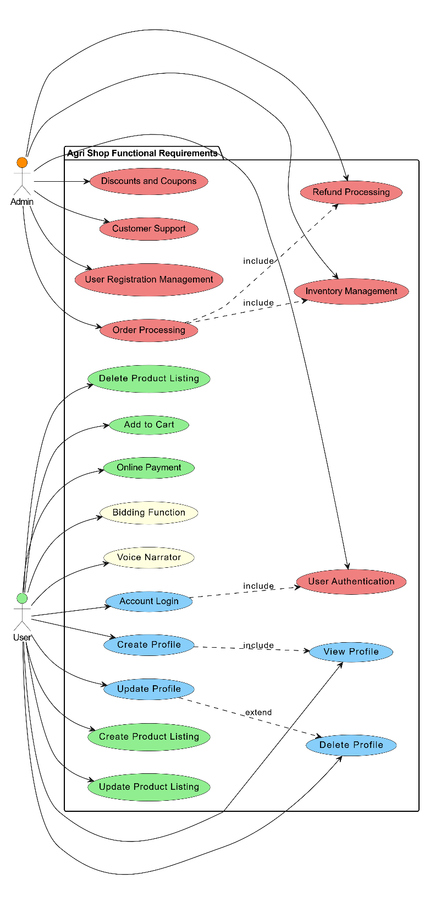
Figure 1 Overall use case diagram

3.2 Create Profile:

Use Case ID | FR_01
Use Case Name | Create Profile
Description | Allows a user to create a new profile on the Agri Shop web application.
Primary Actor | User
Secondary Actor | None
Pre-Condition | The user must have internet connectivity.
Post-Condition | A new profile is created and saved in the database.
Basic Flow | The user begins by entering their name, email, password, and other necessary details into the designated fields. After ensuring all information is correct, the user clicks the submit button. The system then validates the provided input and, upon successful validation, saves the user's information in the database. Finally, the system confirms that the profile has been created successfully.

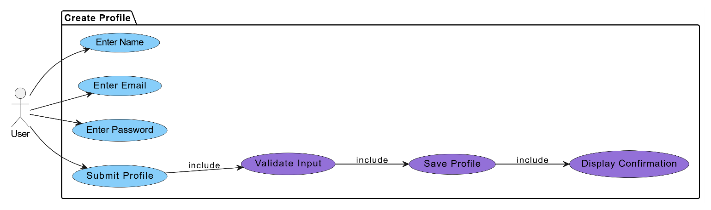
Figure 2 Create profile

3.3 View Profile:

Use Case ID | FR_02
Use Case Name | View Profile
Description | Allows a user to view their profile details on the Agri Shop web application.
Primary Actor | User
Secondary Actor | None
Pre-Condition | The user must be logged in and have an internet connection.
Post-Condition | The user's profile details are displayed on the screen.
Basic Flow | User navigates to the "View Account" page. System retrieves the user's details from the database using the User ID. System displays the user's account details on the screen.

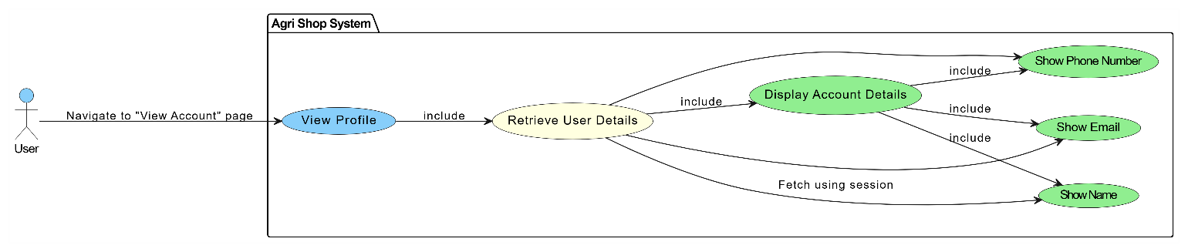
Figure 3 view profile

3.3 Update Profile:

Use Case ID | FR_03
Use Case Name | Update Profile
Description | Allows a user to update their profile details on the Agri Shop mobile application.
Primary Actor | User
Secondary Actor | None
Pre-Condition | The user must be logged in and have an internet connection.
Post-Condition | The user's profile is updated, and a confirmation message is displayed.
Basic Flow | User navigates to the "Update Account" page. User enters new details. User clicks the "Submit" button. System validates the new input. System updates the user record in the database. User receives an "Account updated" confirmation message.

Figure 4 update profile

3.5 Delete profile:
Use Case ID | FR_04
Use Case Name | Delete profile
Description | Allows a user to delete their profile details on the Agri Shop mobile application.
Primary Actor | User
Secondary Actor | None
Pre-Condition | The user must be logged in and have an internet connection.
Post-Condition | The user's profile is deleted, and a confirmation message is displayed.
Basic Flow | User navigates to the "Delete Account" page. User clicks the "Delete Account" button. System asks for confirmation. User confirms account deletion. System deletes the user record from the database. User receives an "Account deleted" confirmation message.

Figure 5 Delete profile

3.6 Account Login:

Use Case ID | FR_05
Use Case Name | Account Login
Description | Allows a user to log in to the Agri Shop mobile application using their email and password.
Primary Actor | User
Secondary Actor | None
Pre-Condition | The user must have a registered account and an internet connection.
Post-Condition | User is logged in, and a success or error message is displayed.
Basic Flow | User navigates to the "Login" page. User enters their Email and Password. User clicks the "Login" button. System validates the email and password. If valid, the system starts a user session and redirects to the dashboard. User receives a "Login successful" message or an error message.

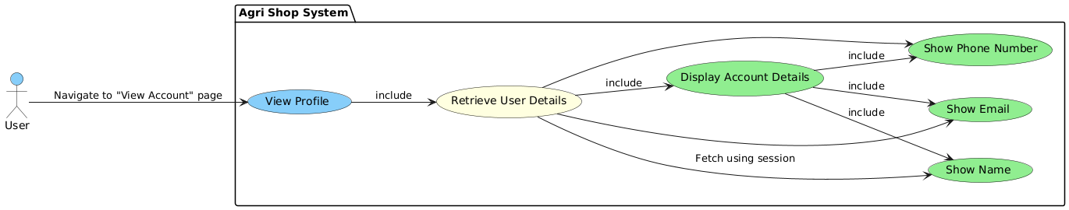
Figure 6 Account Login

3.7 Create Product linsting:

Use Case ID | FR_06
Use Case Name | Create Product Listing
Description | Allows a farmer to create a new product listing by providing details an  Uploading images.
Primary Actor | Farmer
Secondary Actor | None
Pre-Condition | The farmer must have a registered account and an internet connection.
Post-Condition | The product listing is created, and a confirmation message is displayed.
Basic Flow | Farmer navigates to the "Create Product Listing" page. Farmer enters product details and uploads images. Farmer clicks the "Submit" button. System validates the input. System saves the product listing in the database. Farmer receives a "Product listing created" confirmation message.

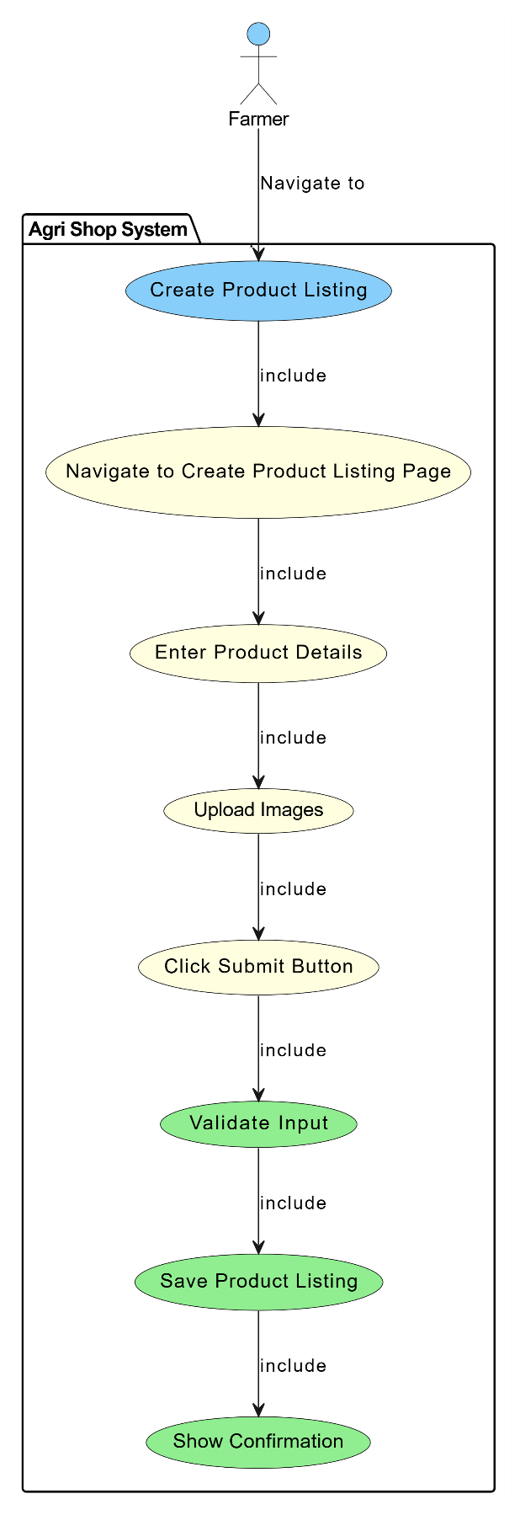
Figure 7 Create Product listing

3.8 Update product list:

Use Case ID | FR_07
Use Case Name | Update product listing
Description | Allows a farmer to update an existing product listing by providing updated details and uploading new images.
Primary Actor | Farmer
Secondary Actor | None
Pre-Condition | The farmer must have a registered account and an internet connection.
Post-Condition | The product listing is updated, and a confirmation message is displayed.
Basic Flow | Farmer navigates to the "Update Product Listing" page. Farmer selects the product to update. Farmer enters updated product details and uploads new images. Farmer clicks the "Submit" button. System validates the new input. System updates the product listing in the database. Farmer receives a "Product listing updated" confirmation message.

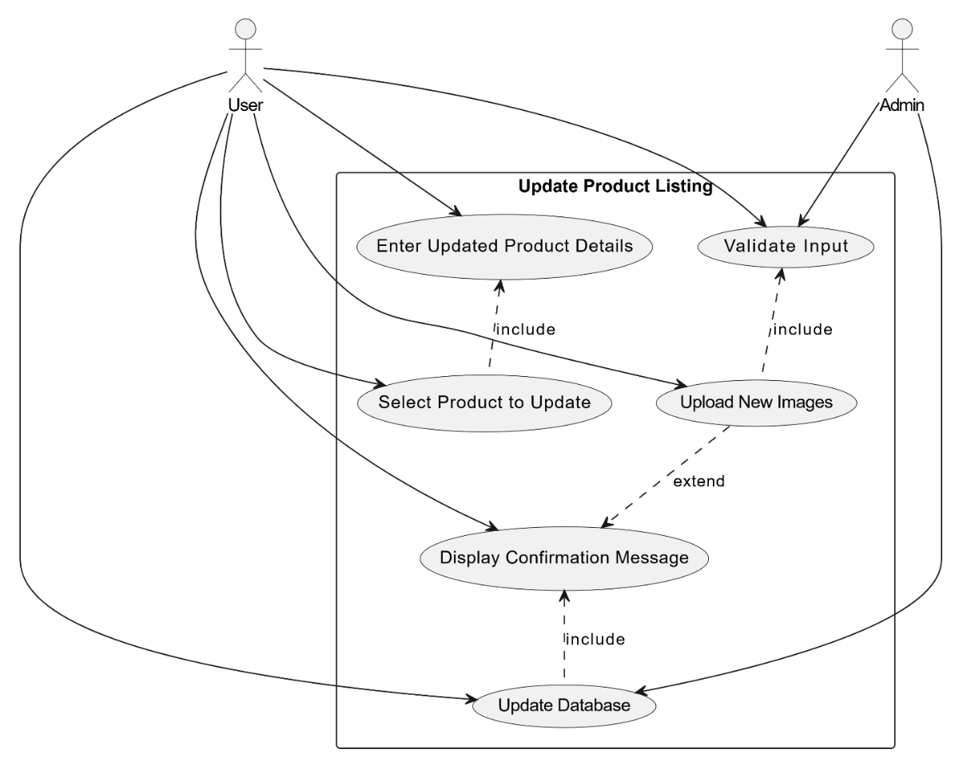
Figure 8 Update Product Listing

3.9 Delete Product Listing:
Use Case ID | FR_08
Use Case Name | Delete Product Listing
Description | Allows a farmer to delete an existing product listing from the system.
Primary Actor | Farmer
Secondary Actor | None
Pre-Condition | The farmer must have a registered account and an internet connection.
Post-Condition | The product listing is deleted, and a confirmation message is displayed.
Basic Flow | Farmer navigates to the "Delete Product Listing" page. Farmer selects the product to delete. Farmer clicks the "Delete" button. System asks for confirmation. Farmer confirms the deletion. System deletes the product listing from the database. Farmer receives a "Product listing deleted" confirmation message.

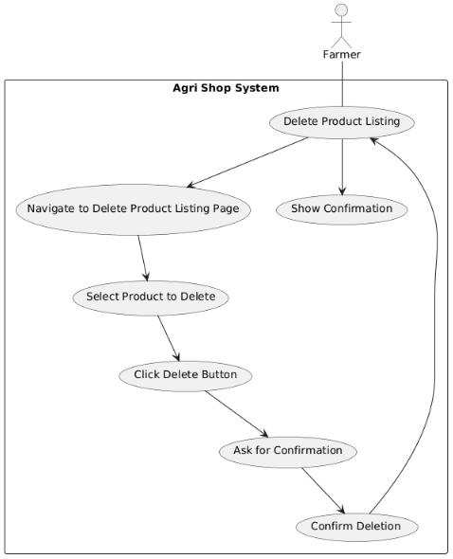
Figure 9 Delete Product listing

3.10 Bidding Function:

Use Case ID | FR_09
Use Case Name | Bidding Function
Description | Allows users to place bids on agricultural products listed for auction, facilitating competitive pricing and fair market value.
Primary Actor | User
Secondary Actor | None
Pre-Condition | The user must be logged in and have an internet connection.
Post-Condition | The bid is placed, and the bid history is updated.
Basic Flow | User navigates to the product listing page that supports bidding. User views the current highest bid and decides on a bid amount. User enters the bid amount and clicks the 'Place Bid' button. The system checks if the bid amount is higher than the current highest bid. If valid, the system records the bid and updates the highest bid information. Display confirmation message to the user and update bid history for the product.

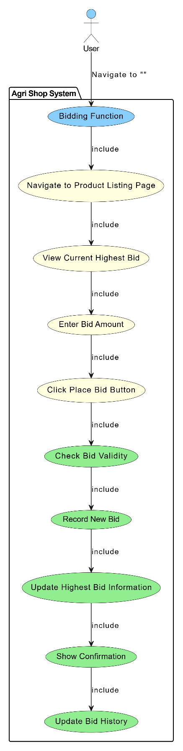
Figure 10 bidding function

3.11 Add to cart:
Use Case ID | FR_10
Use Case Name | Add to cart
Description | Allows users to add products to their virtual shopping cart for later purchase
Primary Actor | User
Secondary Actor | None
Input | Product ID, Quantity
Output | Confirmation message indicating the product has been added to the cart
Basic Flow | User navigates to the product listing page. User selects a product and specifies the quantity. User clicks the 'Add to Cart' button. The system checks the availability of the product. Adds it to the user's shopping cart. Display confirmation message to the user.
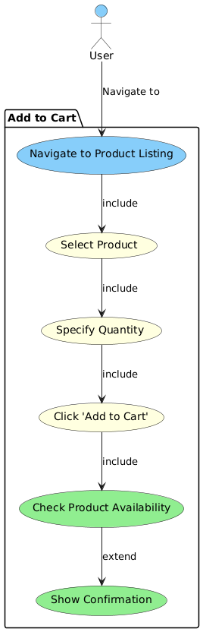
Figure 11 Add to Cart

3.12 Voice narrator:

Use Case ID | FR_11
Use Case Name | Voice narrator
Description | Provides voice narration for key functionalities to assist users who are unable to read or write.
Primary Actor | User
Secondary Actor | None
Input | Text displayed on the screen.
Output | Audio narration of the text.
Basic Flow | Users navigate to a page with text (e.g., registration, product listing). The system detects the text to be narrated. Users click the 'Voice Narrator' button. The system converts the text to speech. Audio narration is played, reading out the text on the screen.

Figure 12 voice narrator

3.13 Online payment:

Use Case ID | FR_12
Use Case Name | Online Payment
Description | Allows users to make secure online payments for products purchased on the Agri Shop Web Application
Primary Actor | User
Secondary Actor | None
Input | Payment Method, Card Details or Digital Wallet Information.
Output | Confirmation message indicating successful payment, updated order status.
Basic Flow | User proceeds to checkout after adding products to the cart. User selects a preferred payment method (e.g., credit card, debit card, digital wallet). User enters required payment details (e.g., card number, expiration date, CVV). User clicks the 'Pay Now' button. The system processes the payment through a secure payment gateway. Display confirmation message to the user and update the order status.

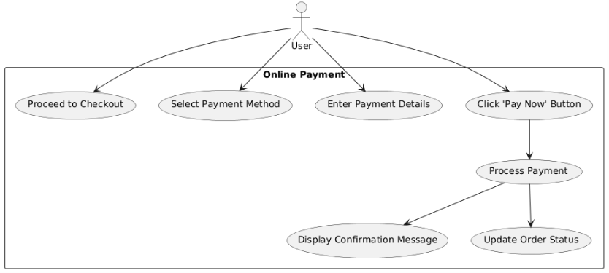
Figure 13 Online Payment

3.14 User Registration Management:

Use Case ID | FR_13
Use Case Name | User Registration Management
Description | Allows admins to approve or reject user registrations.
Primary Actor | Admin
Secondary Actor | None
Input | User registration details.
Output | Confirmation of registration approval or rejection.
Basic Flow | Admin accesses the user registration management section. Admin reviews pending user registration details. Admin approves or rejects the user registration. System updates user status and notifies users via email. Display confirmation message to the admin.

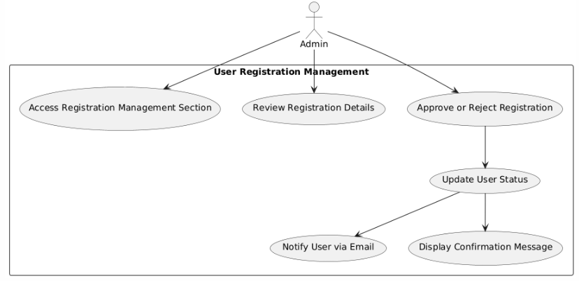
Figure 14 User Registration management

3.15 Inventory management:

Use Case ID | FR_14
Use Case Name | Inventory management
Description | Enables admins to monitor stock levels, update inventory, and manage low stock alerts.
Primary Actor | Admin
Secondary Actor | None
Input | Product ID, Stock quantity
Output | Updated inventory levels, Low stock alerts
Basic Flow | Admin navigates to the inventory management section.Admin enters or updates stock quantities for products.System updates the inventory levels in the database.System generates low stock alerts for products below threshold levels.Display confirmation message to the admin

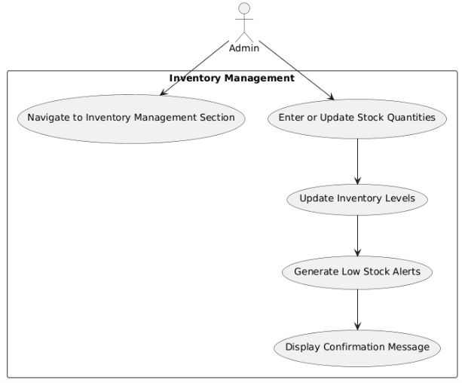
Figure 15 inventory management

3.18 User authentication:

Use Case ID | FR_17
Use Case Name | User authentication
Description | Implements strong authentication mechanisms, including two-factor authentication (2FA), to ensure secure access to the Agri Shop web application.
Input | User credentials (username, password), 2FA code
Output | Access granted or denied messageg
Basic Flow | Users log in with their username and password. If correct, they enter a 2FA code sent to their device. The system verifies the code and grants access if it's correct, otherwise, it shows an error message.

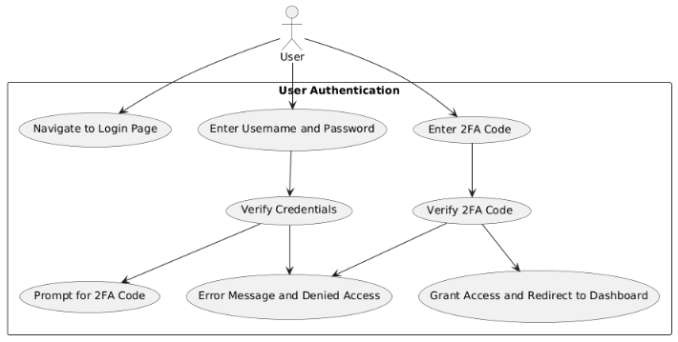
Figure 16User authentication:

3.19 Discounts and Coupons:

Use Case ID | FR_18
Use Case Name | Discounts and Coupons
Description | Allows admins to handle and process refund requests submitted by customers.
Primary Actor | Admin
Secondary Actor | Customer
Input | Discount code details (code, percentage or amount off, expiration date, usage limits)
Output | Confirmation of discount code creation or update
Basic Flow | Admin navigates to the marketing and promotions section. Admin selects the option to add or edit a discount code. Admin enters discount code details including code, percentage or amount off, expiration date, and usage limits. Admin saves the discount code configuration. System updates the discount codes in the database. Display confirmation message to the admin. Customers can enter discount codes during checkout to receive the specified discount

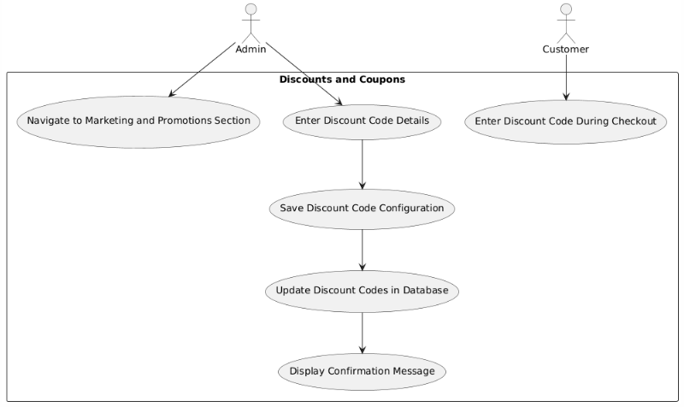
Figure 17 Discounts and Coupons:

3.18 Discounts and Coupons:
Use Case ID | FR_19
Use Case Name | Customer support
Description | Provides tools for managing customer support tickets and inquiries, as well as creating and managing a knowledge base and FAQs to assist customers.
Primary Actor | Admin
Secondary Actor | Customer
Input | Support ticket details (customer name, issue description), FAQ details (question, answer)
Output | Confirmation of ticket resolution or FAQ creation/update
Basic Flow | Customers submit support tickets or inquiries. Admins manage and respond to these tickets, updating their status and notifying customers of resolutions. Admins also add or update FAQs in the knowledge base. The system updates the knowledge base, and customers can access FAQs for self-service support.

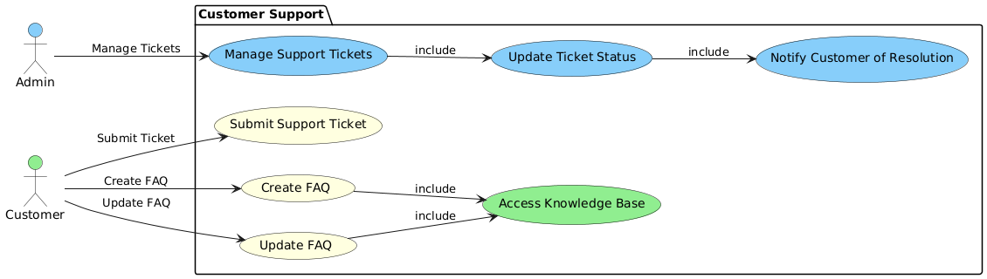
Figure 18 Customer Support

Chapter 4: Design

Architecture Diagram

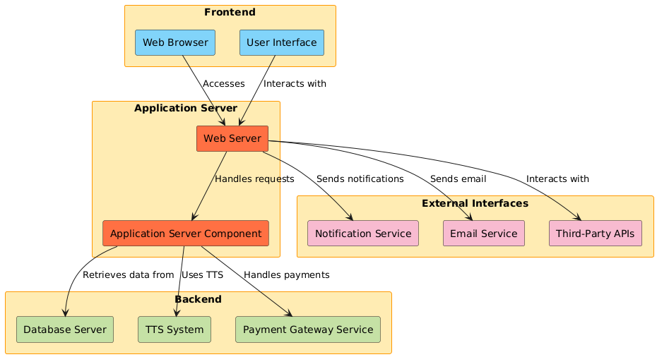

Figure 19 Architecture Diagram

ERD with data dictionary
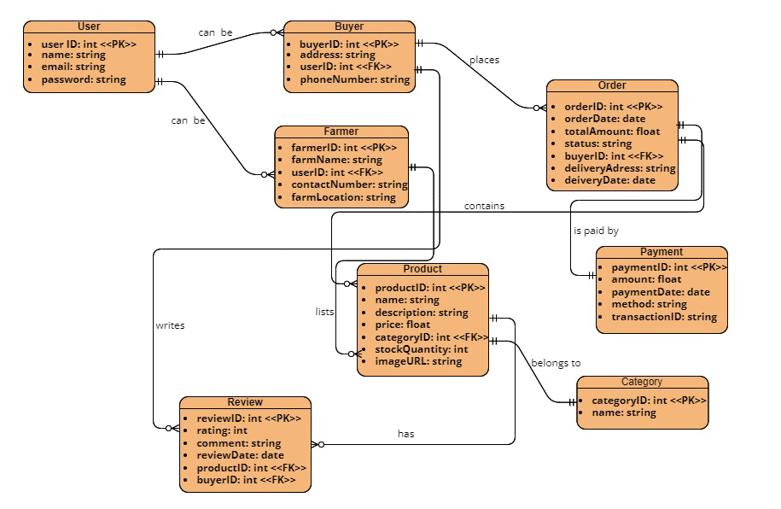

Figure 20 ERD

Data Flow diagram

The level 0
The flow of information inside the system is defined in this level

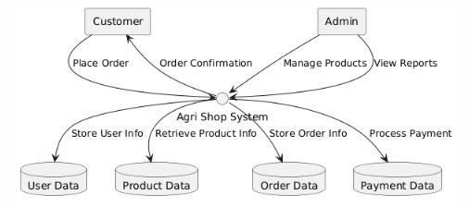
Figure 21 Level 0 DFD

The level 1
The flow of information outside the system is defined in this level

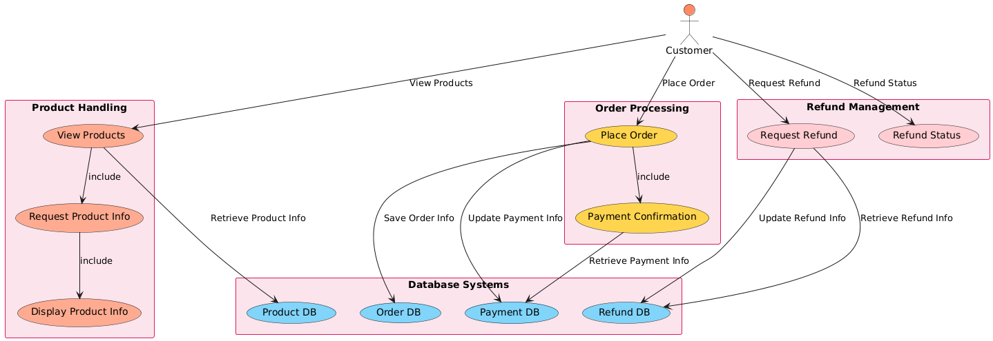
Figure 22 Level 1 DFD

Class Diagram
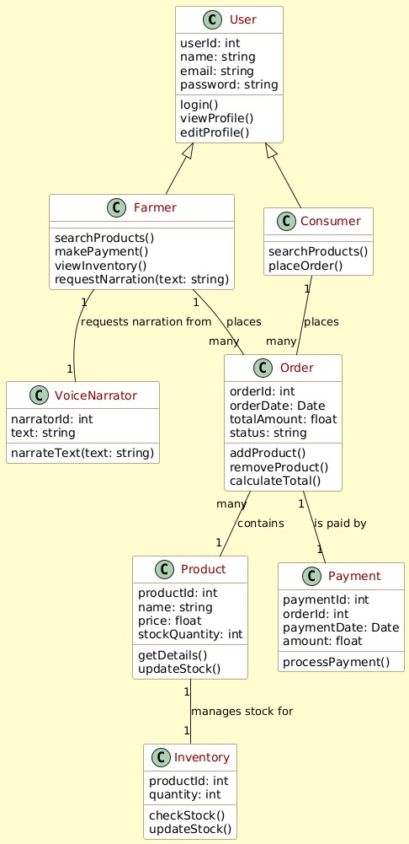

Figure 23 Class Diagram

Activity Diagram

Activity diagram for create account:
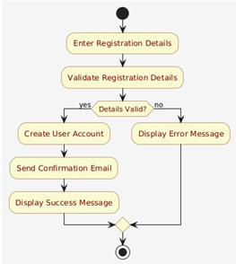

Figure 24 Activity Diagram Create Account

Activity diagram for login account:
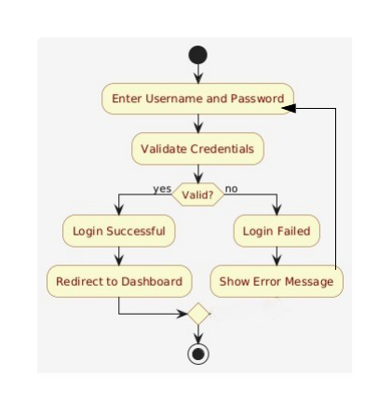
Figure 25 Activity Diagram Create Account

Activity diagram for edit profile:
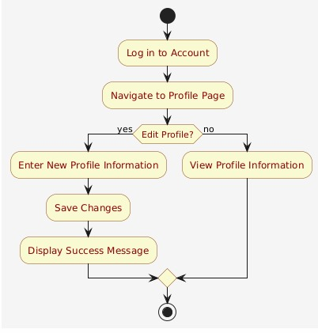
Figure 26 Activity diagram for edit profile

Activity diagram for customer details:
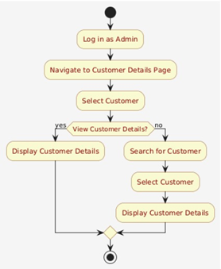
Figure 27 Activity diagram for customer details

Activity diagram for search product:
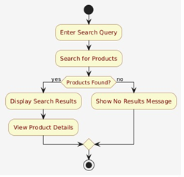
Figure 28 Activity diagram for search product
Activity diagram for Text to Speech:

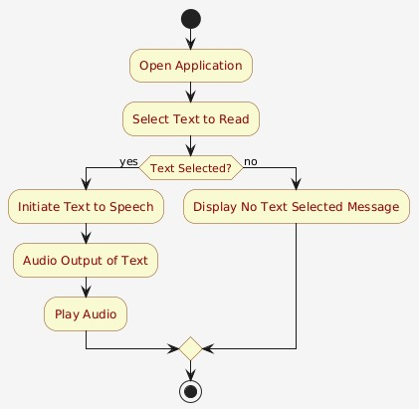
Figure 29 Activity diagram for Text to Speech

Activity diagram for Bidding system:
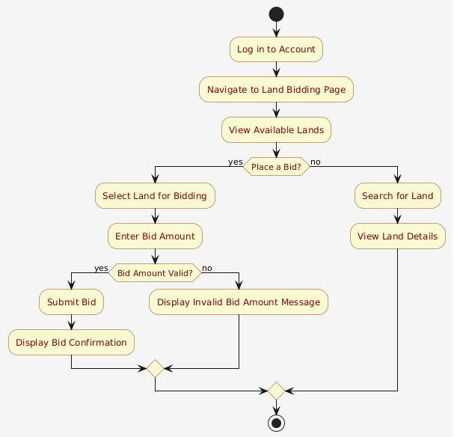
Figure 30 Activity diagram for Bidding system
Activity diagram for inventory:
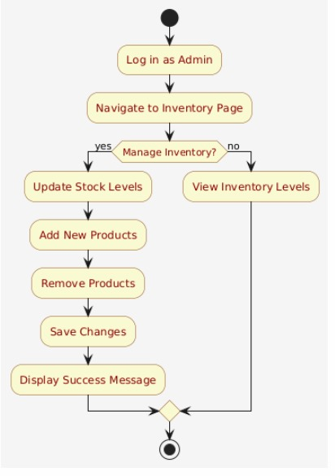
Figure 31Activity diagram for inventory

Activity diagram for payment gateway:
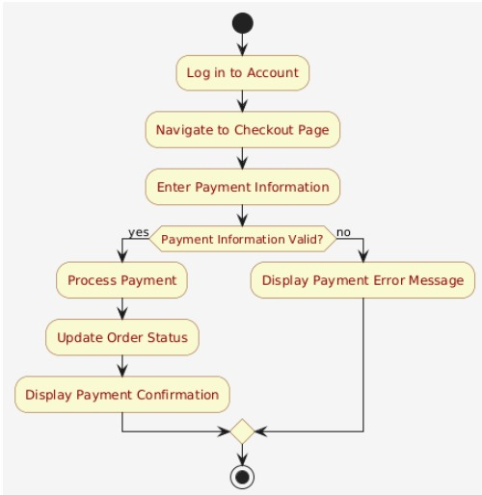
Figure 32 Activity diagram for payment gateway

Sequence Diagram

Sequence diagram for create account

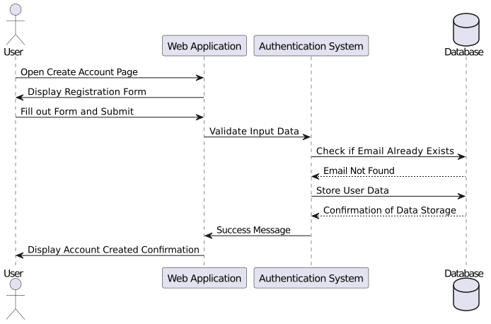
Figure 33 Sequence Diagram Create Account

Sequence diagram for login Account:
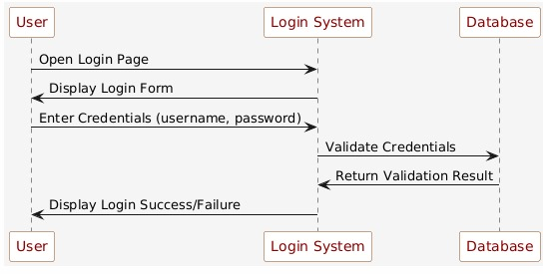
Figure 34 Sequence diagram for login Account

Sequence diagram for search product:
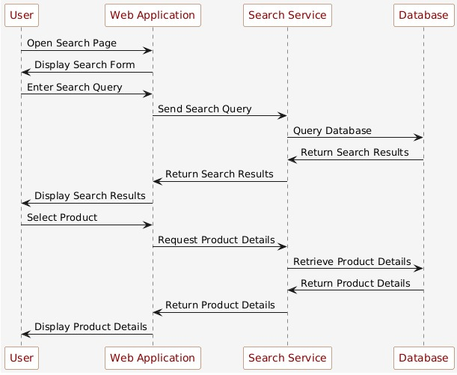
Figure 35 Sequence diagram for search product
Sequence diagram for Inventory management:
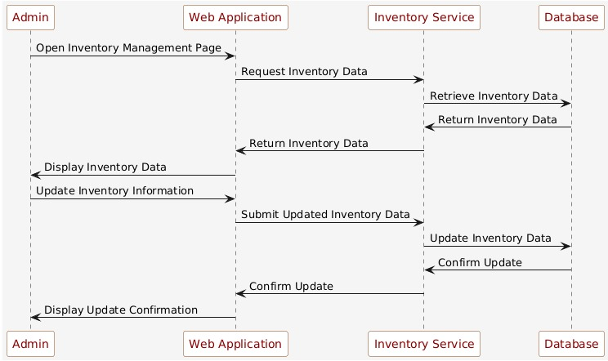
Figure 36 Sequence diagram for Inventory management

Sequence diagram for customer details:
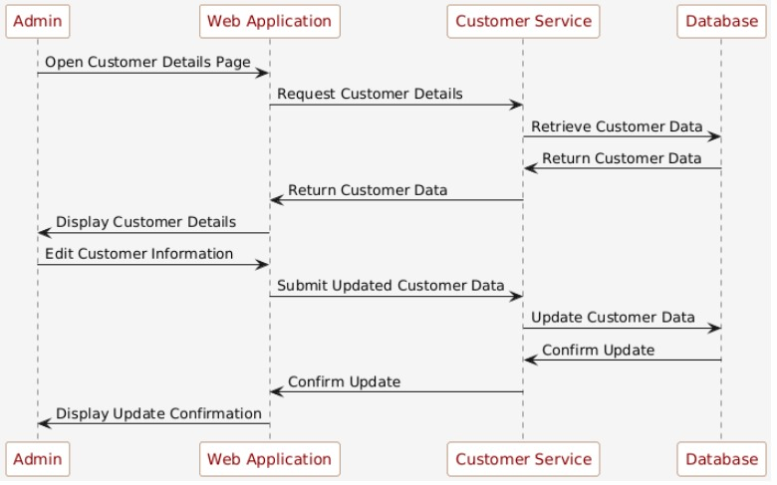
Figure 37 Sequence diagram for customer details
Sequence diagram for payment gateway:
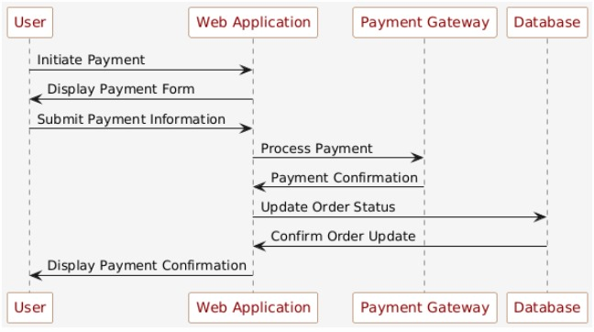
Figure 38 Sequence diagram for payment gateway

Sequence diagram for Bidding System:
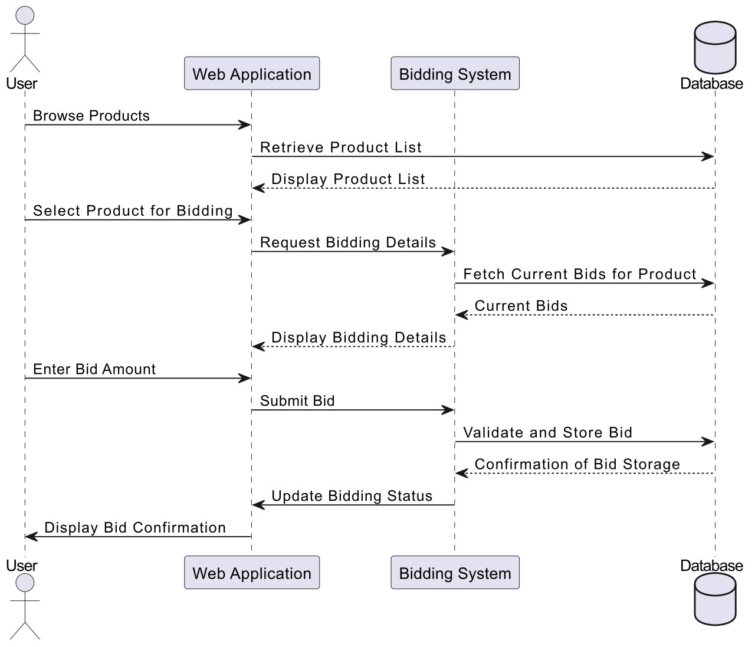
Figure 39 Sequence diagram for Bidding System
Sequence diagram for Text to speech:
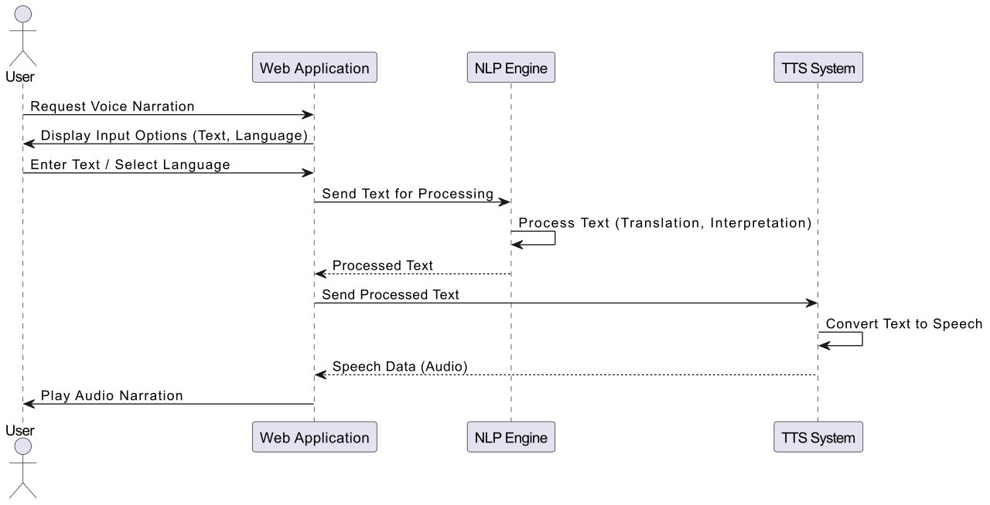
Figure 40 Sequence diagram for Text to speech

Aggregated Sequence Diagram:
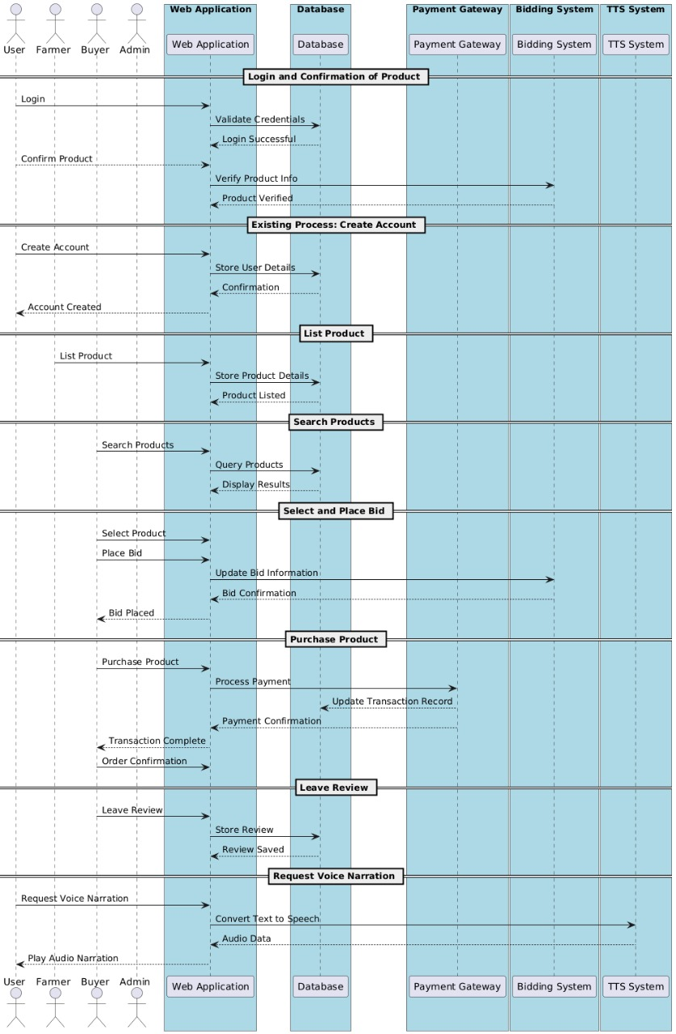

Figure 41 Aggregated Sequence Diagram

Collaboration Diagram

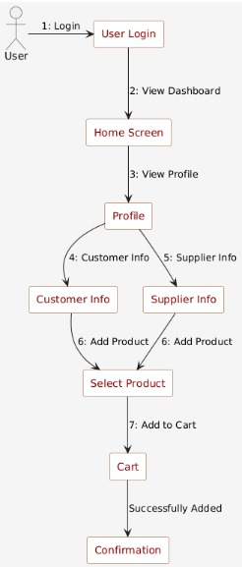

Figure 42 Collaboration Diagram

State Transition Diagram
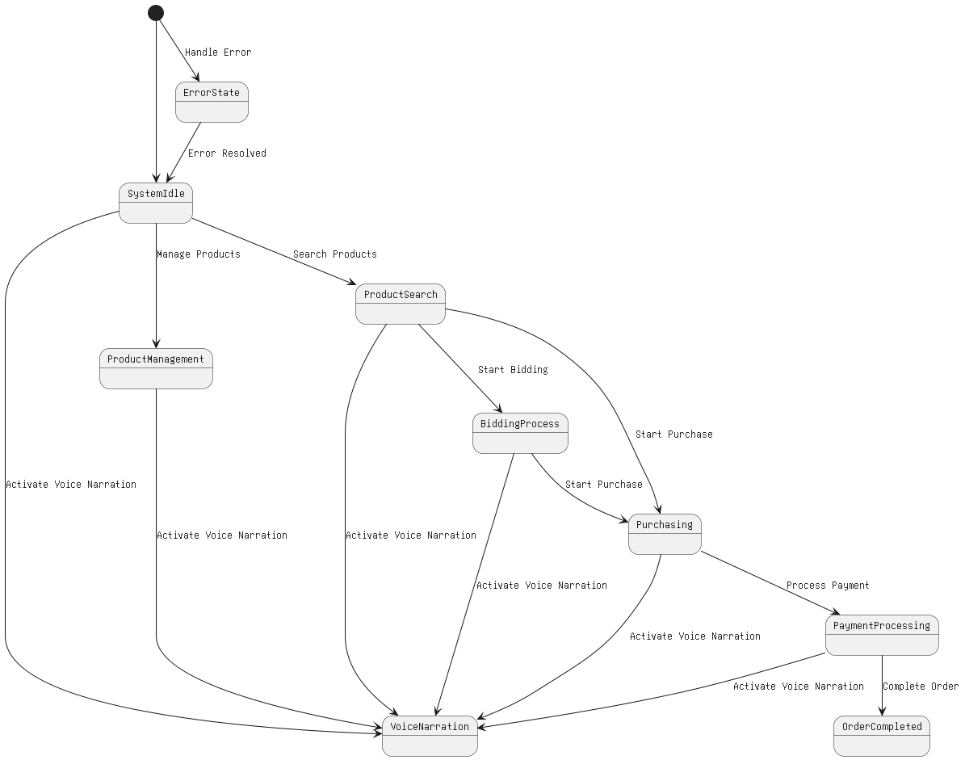
Figure 43 State Transition Diagram

Component Diagram

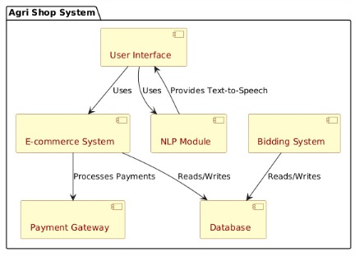

Figure 44 Component Diagram

Deployment Diagram
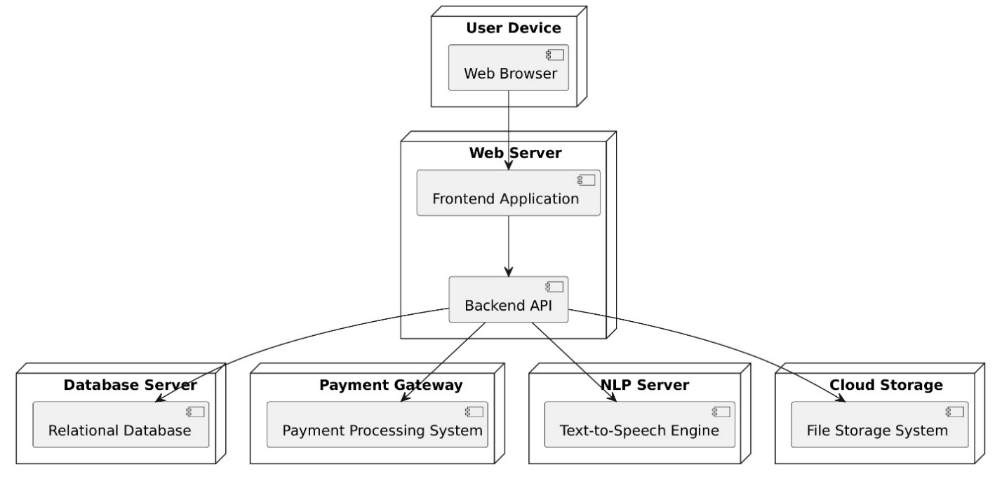
Figure 45 Deployment Diagram

Chapter 5: Testing

Test Case Specifications
This Testing phase includes all the Test Cases of the functional requirements of your project
For example, your login account test case looks like this and you have to follow this template for writing your project test cases
Test Case for Create Profile
 | Positive Test Case
ID | TC_CREATE_PROFILE_SUCCESS
Priority | High
Description | To verify successful creation of a user profile with valid inputs.
Reference | FR_01 (Create Profile)
Users | Administrator, Farmers, Consumers.
Pre-requisites | A | System is online.
 | B | User must have active login credentials provided by system administrator.
 | C | User has internet access.
Steps | A | Open the "Create Profile" page.
 | B | Enter valid details (e.g., Name, Email, Password, etc.).
 | C | Click the "Submit" button.
Input | User details: name, email, phone number, password.
Expected result | The system successfully creates the profile and displays a confirmation message.
Status | Tested, passed.

Table 21 Positive Test Case for creating profile

 | Negative Test Case
ID | TC_CREATE_PROFILE_FAILURE
Priority | High
Description | To verify the profile creation process with missing or invalid inputs.
Reference | FR_01 (Create Profile)
Users | Administrator, Farmers, Consumers
Pre-requisites | A | System is online.
 | B | User has internet access.
Steps | A | Open the "Create Profile" page.
 | B | Enter invalid or incomplete details (e.g., missing Email, Password less than 6 characters).
 | C | Click the "Submit" button.
Input | Incorrect Phone number or password or deactivated credentials.
Expected result | The system prevents profile creation and displays an error message.
Status | Tested, passed.

Table 22 Negative Test Case

 | Positive Test Case
ID | TC_BIDDING_SUCCESS
Priority | High
Description | Verify that the user can successfully place a bid.
Reference | FR_09 (Bidding system)
Users | Administrator, Farmers, Consumers.
Pre-requisites | A | User must be logged in.
 | B | User must have internet access.
 | C | Product must be listed for bidding.
Steps | A | Log into the system.
 | B | Navigate to a product listing with bidding enabled.
 | C  D | Enter a bid amount higher than the current bid.  Click "Place Bid".
Input | Product ID: 67890  Bid Amount: "10.00"
Expected result | The system accepts the bid and updates the bid history.
Status | Tested, passed.

 | Negative Test Case
ID | TC_BIDDING_SUCCESS
Priority | High
Description | Verify that the user can successfully place a bid.
Reference | FR_09
Users | Farmers, Consumers.
Pre-requisites | A | User must be logged in.
 | B | User must have internet access.
 | C | Product must be listed for bidding.
Steps | A | Log into the system.
 | B | Navigate to a product listing with bidding enabled.
 | C  D | Enter a bid amount higher than the current bid.  Click "Place Bid".
Input | Product ID: 67890  Bid Amount: "5.00" (current highest bid is "10.00")
Expected result | The system rejects the bid and shows an error message (e.g., "Bid must be higher than the current bid.").
Status | Tested, passed.

 | Positive Test Case
ID | TC_ADD_TO_CART_SUCCESS
Priority | High
Description | Verify that the user can successfully add a product to their shopping cart.
Reference | FR_010 (Add to cart)
Users | Consumers.
Pre-requisites | A | User must be logged in.
 | B | User must have internet access.
 | C | Product must be available.
Steps | A | Log into the system.
 | B | Navigate to a product listing
 | C  D | Select the desired quantity.  Click the "Add to Cart" button.
Input | Product ID: 23456  Quantity: "2"
Expected result | The system successfully adds the product to the cart and displays a confirmation message.
Status | Tested, passed.

 | Negative Test Case
ID | TC_ADD_TO_CART_FAILUREW
Priority | High
Description | Verify that the system does not allow adding a product to the cart if the desired quantity exceeds available stock.
Reference | FR_010 (Add to cart)
Users | Consumers.
Pre-requisites | A | User must be logged in.
 | B | User must have internet access.
 | C | Product must be available but with limited stock (e.g., less than the desired quantity).
Steps | A | Log into the system.
 | B | Navigate to a product listing
 | C  D | Select a quantity greater than available stock.  Click the "Add to Cart" button.
Input | Product ID: 23456  Quantity: "10" (if available stock is "5")
Expected result | The system rejects the request and displays an error message (e.g., "Requested quantity exceeds available stock.").
Status | Tested, passed.

 | Positive Test Case
ID | TC_VOICE_NARRATOR_SUCCESS
Priority | High
Description | Verify that the voice narrator reads the displayed text on the screen.
Reference | FR_011 Voice narrator)
Users | Consumers, Farmers
Pre-requisites | A | User must be logged in.
 | B | User must have internet access.
 | C | Text should be available for narration..
Steps | A | Log into the system.
 | B | Navigate to a product listing
 | C | Navigate to a page with displayed text (e.g., registration page, product listing).  Click the "Add to Cart" button.
 | D | Click the "Voice Narrator" button.
Input | Text on the page (e.g., "Welcome to Agri Shop")
Expected result | The system reads the text aloud via the voice narrator.
Status | Tested, passed.

 | Negative Test Case
ID | TC_VOICE_NARRATOR_FAILURE
Priority | High
Description | Verify that the system displays an error message when the voice narrator is unable to process the text.
Reference | FR_011 (Voice narrator)
Users | Consumers, Farmers
Pre-requisites | A | User must be logged in.
 | B | User must have internet access.
 | C | Text must be unavailable or corrupted.
Steps | A | Log into the system.
 | B | Navigate to a page with no displayed text or corrupted text.
 | C | Click the "Voice Narrator" button.
Input | Text on the page: Empty or invalid text (e.g., special characters like "###$$$%%%")
Expected result | The system does not read the text and displays an error message (e.g., "Unable to process text for narration.").
Status | Tested, passed.

 | Positive Test Case
ID | TC_ONLINE_PAYMENT_SUCCESS
Priority | High
Description | Verify that the user can successfully make an online payment for the products.
Reference | FR_012 (Online payment)
Users | Consumers
Pre-requisites | A | User must be logged in.
 | B | User must have internet access.
 | C  D | Product(s) must be added to the cart.  Invalid payment details (e.g., expired credit card).
Steps | A | Log into the system.
 | B | Add products to the cart.
 | C  D  E  F | Navigate to the checkout page.  Select a payment method  Enter invalid or expired payment details (e.g., expired credit card).  Click the "Pay Now" button.
Input | Payment Method: Credit card  Card Number: "4111111111111111"  CVV: "123"  Expiration Date: "01/2020" (expired)
Expected result | The system rejects the payment and displays an error message (e.g., "Payment failed. Please check your card details.").
Status | Tested, passed.

 | Negative Test Case
ID | TC_ONLINE_PAYMENT_FAILURE
Priority | High
Description | Verify that the user cannot make an online payment with invalid or expired payment details.
Reference | FR_012 (Online payment)
Users | Consumers
Pre-requisites | A | User must be logged in.
 | B | User must have internet access.
 | C  D | Product(s) must be added to the cart.  A valid payment method (e.g., credit card, digital wallet) is available
Steps | A | Log into the system.
 | B | Add products to the cart.
 | C  D  E  F | Navigate to the checkout page.  Select a valid payment method  Enter payment details (e.g., card number, CVV).  Click the "Pay Now" button.
Input | Payment Method: Credit card  Card Number: "4111111111111111"  CVV: "123"  Expiration Date: "12/2025"
Expected result | The system processes the payment successfully and updates the order status to "Paid".
Status | Tested, passed.

 | Positive Test Case
ID | TC_USER_REGISTRATION_APPROVE_SUCCESS
Priority | High
Description | Verify that the admin can successfully approve a user registration request.
Reference | FR_013 (User registration approvel)
Users | Admin
Pre-requisites | A | User registration request must be pending.
 | B | Admin must be logged in.
Steps | A | Log into the system as an admin.
 | B | Navigate to the "User Registration Management" section.
 | C  D | Review the pending registration requests.  Approve a user's registration.
Input | User Registration Request: "Alies Doe, aliesdoe@example.com"
Expected result | The system successfully approves the user registration and sends a confirmation email to the user.
Status | Tested, passed.

 | Negative Test Case
ID | TC_USER_REGISTRATION_APPROVE_FAILURE
Priority | High
Description | Verify that the admin can successfully approve a user registration request.
Reference | FR_013 (User registration approval)
Users | Admin
Pre-requisites | A | User registration request must be pending.
 | B | Admin must be logged in.
Steps | A | Log into the system as an admin.
 | B | Navigate to the "User Registration Management" section.
 | C  D | Review the pending registration requests.  Reject a user's registration.
Input | User Registration Request: "Allies Doe, alliesdoe@example.com"
Expected result | The system successfully approves the user registration and sends a confirmation email to the user.
Status | Tested, passed.

 | Positeve Test Case
ID | TC_INVENTORY_UPDATE_SUCCESS
Priority | High
Description | Verify that the admin can successfully update the inventory of a product.
Reference | FR_14 (Inventory update)
Users | Admin
Pre-requisites | A | Admin must be logged in and have internet access.
 | B | Product must exist in the inventory.
Steps | A | Log into the system as an admin.
 | B | Navigate to the "Inventory Management" section.
 | C  D  E | Select a product to update.  Update the stock quantity (e.g., increase or decrease inventory).  Click "Save".
Input | Product ID: 12345  New Stock Quantity: "200"
Expected result | The system successfully updates the inventory and displays a confirmation message.
Status | Tested, passed.

 | Negative Test Case
ID | TC_INVENTORY_UPDATE_FAILURE
Priority | High
Description | Verify that the admin cannot update the inventory with invalid or incomplete details.
Reference | FR_14 (Inventory update)
Users | Admin
Pre-requisites | A | Admin must be logged in and have internet access.
 | B | Product must exist in the inventory.
Steps | A | Log into the system as an admin.
 | B | Navigate to the "Inventory Management" section.
 | C  D  E | Select a product to update.  Enter invalid stock quantity (e.g., a negative number).  Click "Save".
Input | Product ID: 12345  New Stock Quantity: "-50" (invalid)
Expected result | The system prevents the update and shows an error message (e.g., "Stock quantity cannot be negative.").
Status | Tested, passed.

Black Box Test Cases

Black box testing also known as Behavioral Testing, is a software testing method in which the internal structure/ design/ implementation of the item being tested is not known to the tester. These tests can be functional or non-functional, though usually functional.
This method is named so because the software program, in the eyes of the tester, is like a black box; inside which one cannot see. This method attempts to find errors in the following categories:
- Incorrect or missing functions
- Interface errors
- Errors in data structures or external database access
- Behavior or performance errors
- Initialization and termination errors

Test Case 11: Create Profile

ID | BB_TC_01
Description | Verify that a user (farmer or consumer) can successfully create a profile with valid information.
Preconditions | User is logged in, and the system is operational.
Input | Valid user profile details (e.g., name, email, password, address, etc.).
Steps |  | - Log into the system as a user.
- Navigate to the "Create Profile" section.
- Enter all required profile details
- Click the "Submit" button

Expected Output | The profile is successfully created, and the system shows a confirmation message.
Success Criteria | The user profile is created with all entered details and stored correctly in the system.

Test Case 12: View Profile

ID | BB_TC_02
Description | Verify that a user can view their profile details after logging into the system.
Preconditions | User is logged in, and the profile exists.
Input | Request to view the profile (e.g., by clicking "View Profile" button).
Steps |  | - Log into the system as a user.
- Navigate to the "View Profile" section.
- Click the "View Profile" button.

Expected Output | The user’s profile is displayed with all stored details.
Success Criteria | All details entered in the profile are visible and correct.

Test Case 13: Inventory Management

ID | BB_TC_03
Description | Verify that the admin can successfully manage the inventory, including updating stock levels and product details.
Preconditions | Admin is logged in, and products are available in the inventory.
Input | Updated product details (e.g., quantity, price, description).
Steps |  | - Log into the system as a user.
- Navigate to the "Inventory Management" section
- Select a product to update.
- Update product details (e.g., stock quantity or price).
- Click "Save".
Expected Output | The product is added to the cart successfully.
Success Criteria | The cart is updated with the correct product and quantity.

Test Case 14: Bidding Function

ID | BB_TC_04
Description | Verify that consumers can successfully place bids on available products.
Preconditions | Consumer is logged in, and the product is listed for bidding.
Input | Bid amount for the product.
Steps |  | - Log into the system as a consumer.
- Browse the listed products to find one available for bidding
- Place a bid on the selected product.
Expected Output | The product is added to the cart successfully.
Success Criteria | The cart is updated with the correct product and quantity.

Test Case 15: Add to cart

ID | BB_TC_05
Description | Verify that the user can successfully add products to their shopping cart.
Preconditions | User is logged in, and products are available for purchase.
Input | Product details (e.g., name, quantity) and user action to add the product to the cart.
Steps |  | - Log into the system as a consumer.
- Browse products and select an item.
- Select quantity and click "Add to Cart"..

Expected Output | The product is added to the cart successfully.
Success Criteria | The cart is updated with the correct product and quantity.

Test Case 16: Voice Narrator

ID | BB_TC_06
Description | Verify that the voice narrator reads the displayed text, such as product descriptions or user instructions.
Preconditions | User is logged in, and the text is available for narration.
Input | Text that is displayed on the screen for narration.
Steps |  | - Log into the system.
- Navigate to a page with displayed text (e.g., product listing, instructions).
- Click on the "Voice Narrator" button.

Expected Output | The system reads the text aloud through the voice narrator.
Success Criteria | The voice narrator successfully reads the text aloud as specified.

Test Case 17: Online Payment

ID | BB_TC_07
Description | Verify that the consumer can successfully make an online payment for the products in the cart..
Preconditions | User is logged in, products are in the cart, and valid payment details are available.
Input | Payment details (e.g., credit card information or digital wallet).
Steps |  | - Navigate to the checkout page.  - Select a payment method.  - Enter valid payment details (e.g., credit card number, expiration date).  - Confirm the payment.
Expected Output | The payment is successfully processed, and the order status is updated to "Paid."
Success Criteria | The payment is completed without errors, and the order reflects the payment status.

Test Case 18: User Registration Management

ID | BB_TC_08
Description | Verify that the admin can manage user registrations, including approving or rejecting user accounts.
Preconditions | Admin is logged in, and user registrations are pending.
Input | User registration details (e.g., name, email, role).  Steps:
Steps |  | - Log into the system as an admin.  - Navigate to the "User Registration Management" section.  - Approve or reject pending registration requests.
Expected Output | The user registration status is updated to "Approved" or "Rejected" as per the admin's action.
Success Criteria | The system updates the user registration status correctly and sends notifications (e.g., approval or rejection email)

Equivalence Partitions (EP)
Equivalence class partitioning (EP) is a very widely used method to decrease the number of possible test cases that are required to test a system.
Let see the example of Equivalence Partitions for login Authentication

Variables | Valid Classes |  | Invalid Classes
Username | 1. 2.  3. | Only username “admin”.  Case in-sensitive.  Compulsory field. | - Alphabets, digits and symbols other than “admin”.  - Empty Field.
Password | 1.  2. | Length should be greater than 5 characters.  May contain symbols, alphabets [a-z A-Z] and digits [0-9]. | - Length less than 5 characters.  - Empty field.

Table 23 Valid Classes and Invalid Classes

Boundary Value Analysis
A boundary value is an input or output value on the border of an equivalence partition, includes minimum and maximum values at inside and outside boundaries. Normally Boundary value analysis is part of stress and negative testing.

Decision Table Testing
Decision Table is a testing method, which aims to ensure that each one of the possible branch from each decision point is executed at least once and thereby ensuring that all reachable code is executed.
Create Profile (FR_01)
Conditions:
- C1: Username length is valid (>= 5 characters).
- C2: Email format is valid.
- C3: Password length is valid (>= 6 characters).
- C4: All required fields are filled.
Actions:
- A1: Profile is successfully created.
- A2: Error message for invalid input.
C1 | C2 | C3 | C4 | A1 | A2
Yes | Yes | Yes | Yes | Profile created
Yes | Yes | No | Yes |  | Password too short
Yes | No | Yes | Yes |  | Invalid email format
No | Yes | Yes | Yes |  | Username too short
Yes | Yes | Yes | No |  | Missing field

2. Product Listing Creation (FR_06)
Conditions:
- C1: Product name length is valid (>= 3 characters).
- C2: Price is valid (greater than 0).
- C3: Quantity is valid (greater than 0).
Actions:
- A1: Product listing is successfully created.
- A2: Error message for invalid product details.
C1 | C2 | C3 | A1 | A2
Yes | Yes | Yes | Product created
Yes | No | Yes |  | Invalid price
Yes | Yes | No |  | Invalid quantity
No | Yes | Yes |  | Invalid product name

3. Bidding Function (FR_09)
Conditions:
- C1: User is a consumer (valid role).
- C2: Bid amount is higher than the current bid.
- C3: Product is available for bidding.
Actions:
- A1: Bid is successfully placed.
- A2: Error message for invalid bid (e.g., bid lower than current bid).
C1 | C2 | C3 | A1 | A2
Yes | Yes | Yes | Bid placed
Yes | No | Yes |  | Bid lower than current bid
Yes | Yes | No |  | Product not available for bid
No | Yes | Yes |  | Invalid user role

4. Online Payment (FR_12)
Conditions:
- C1: Payment method is valid (e.g., credit card or digital wallet).
- C2: Payment amount is correct (matches order total).
- C3: Card details are valid.
Actions:
- A1: Payment successfully processed.
- A2: Error message for invalid payment.
C1 | C2 | C3 | A1 | A2
Yes | Yes | Yes | Payment processed
Yes | No | Yes |  | Incorrect payment amount
Yes | Yes | No |  | Invalid card details
No | Yes | Yes |  | Unsupported payment method

5. Add to Cart (FR_10)
Conditions:
- C1: Product is in stock.
- C2: Quantity requested is valid (greater than 0).
- C3: User is logged in.
Actions:
- A1: Product added to cart.
- A2: Error message for invalid cart addition.
C1 | C2 | C3 | A1 | A2
Yes | Yes | Yes | Product added
No | Yes | Yes |  | Product out of stock
Yes | No | Yes |  | Invalid quantity
Yes | Yes | No |  | User not logged in

6. Voice Narrator (FR_11)
Conditions:
- C1: Text is available for narration.
- C2: Audio output is supported (device capable of playing audio).
- C3: User clicks on "Voice Narrator" button.
Actions:
- A1: Text is read aloud by the voice narrator.
- A2: Error message for issues with audio output.
C1 | C2 | C3 | A1 | A2
Yes | Yes | Yes | Text narrated
No | Yes | Yes |  | No text available
Yes | No | Yes |  | No audio output
Yes | Yes | No |  | Button does not trigger

State transition Testing
State Transition testing, a black box testing technique, in which outputs are triggered by changes to the input conditions or changes to 'state' of the system. In other words, tests are designed to execute valid and invalid state transitions.

Registration:
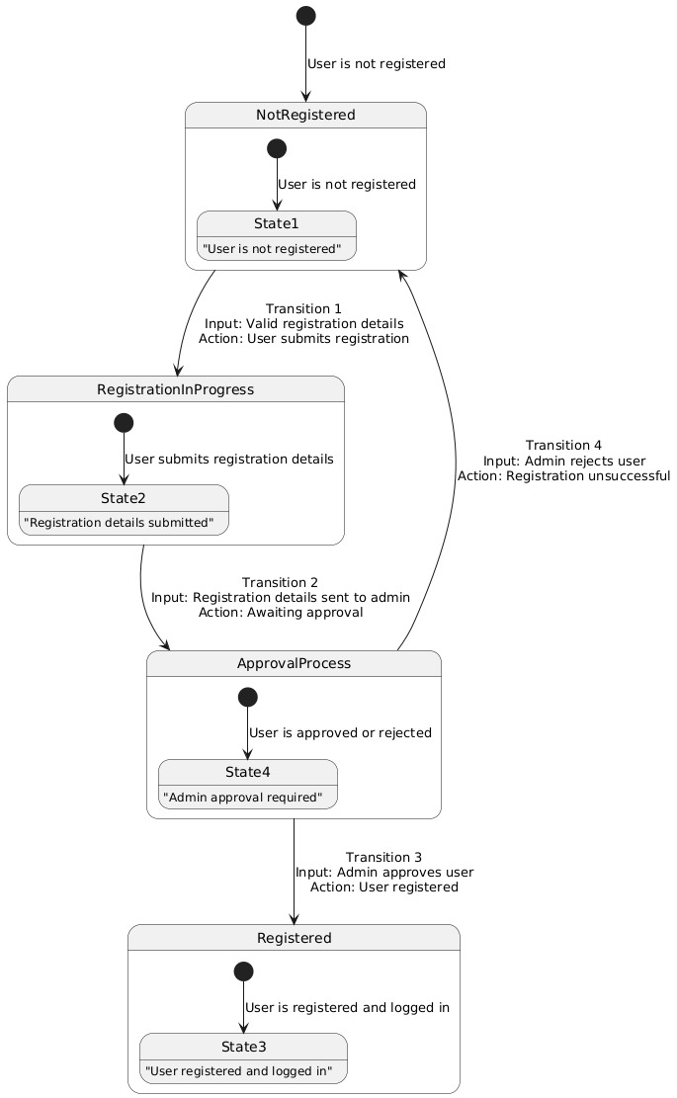

Add to cart :
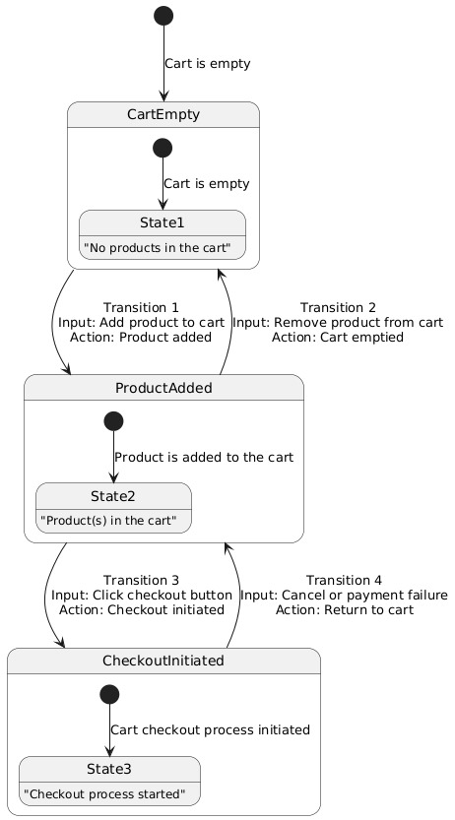

Product List:
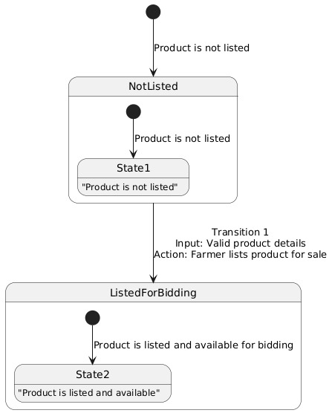

Voice narrator:
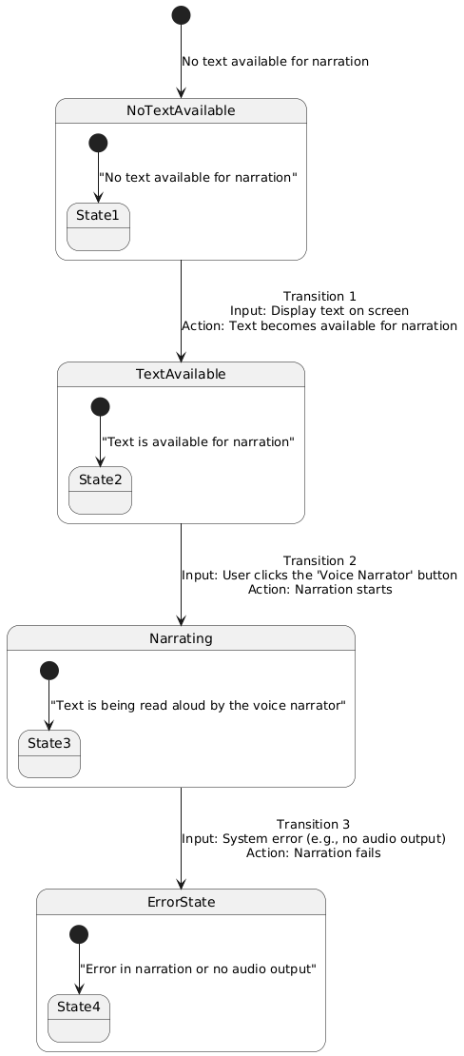

Bidding system
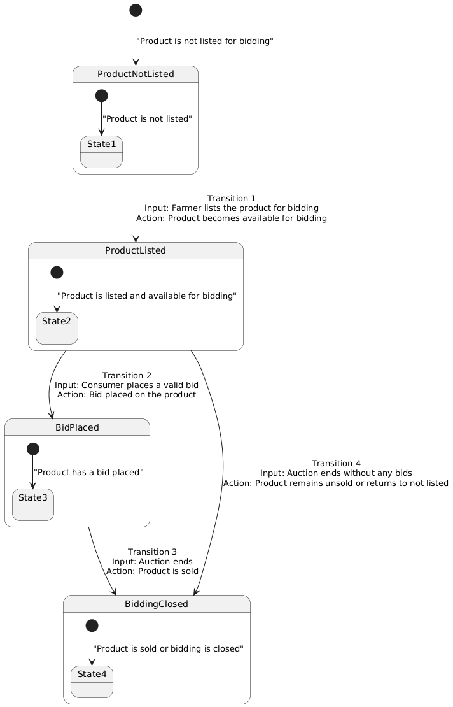

Use Case Testing
Use Case Testing is a functional black box testing technique that helps testers to identify test scenarios that exercise the whole system on each transaction basis from start to finish.
Product listing:
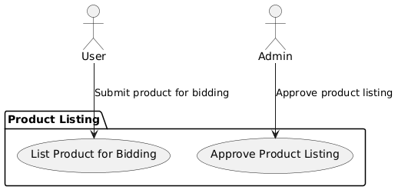
Bidding system:
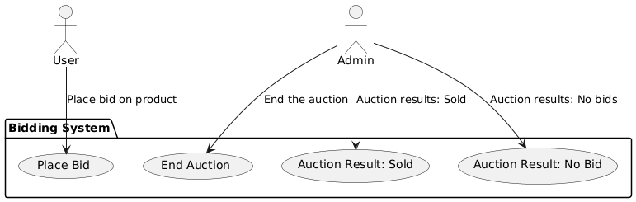
Add to cart:
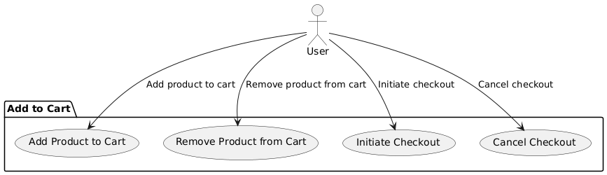

Voice narrator:

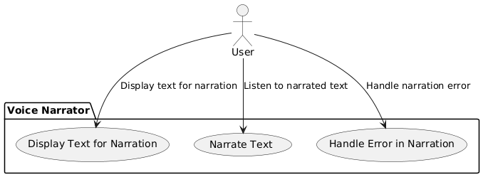

Payement process:

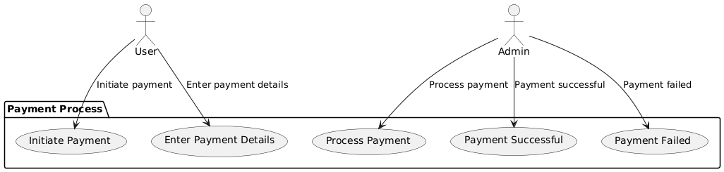

White Box Test Cases
White box testing is a testing technique, that examines the program structure and derives test data from the program logic/code. The other names of glass box testing are clear box testing, open box testing, logic driven testing or path driven testing or structural testing.

Cyclometric complexity
Cyclometric complexity is a source code complexity measurement that is being correlated to a number of coding errors. It is calculated by developing a Control Flow Graph of the code that measures the number of linearly-independent paths through a program module.
Lower the Program's cyclometric complexity, lower the risk to modify and easier to understand.

Performance testing
Performance testing, a non-functional testing technique performed to determine the system parameters in terms of responsiveness and stability under various workload. Performance testing measures the quality attributes of the system, such as scalability, reliability and resource usage.

Stress Testing
Stress testing a Non-Functional testing technique that is performed as part of performance testing. During stress testing, the system is monitored after subjecting the system to overload to ensure that the system can sustain the stress.
The recovery of the system from such phase (after stress) is very critical as it is highly likely to happen in production environment.

System Testing
System Testing (ST) is a black box testing technique performed to evaluate the complete system the system's compliance against specified requirements. In System testing, the functionalities of the system are tested from an end-to-end perspective.
System Testing is usually carried out by a team that is independent of the development team in order to measure the quality of the system unbiased. It includes both functional and NonFunctional testing.

Regression Testing
Regression testing a black box testing technique that consists of re-executing those tests that are impacted by the code changes. These tests should be executed as often as possible throughout the software development life cycle. Types of Regression Tests:

Final Regression Tests
A "final regression testing" is performed to validate the build that hasn't changed for a period of time. This build is deployed or shipped to customers.

Regression Tests
A normal regression testing is performed to verify if the build has NOT broken any other parts of the application by the recent code changes for defect fixing or for enhancement.

Selecting Regression Tests
- Requires knowledge about the system and how it affects by the existing functionalities.
- Tests are selected based on the area of frequent defects.
- Tests are selected to include the area, which has undergone code changes many a times.
- Tests are selected based on the criticality of the features.

Regression Testing Steps
Regression tests are the ideal cases of automation which results in better Return on Investment (ROI).
- Select the Tests for Regression.
- Choose the apt tool and automate the Regression Tests
- Verify applications with Checkpoints
- Manage Regression Tests/update when required
- Schedule the tests
- Integrate with the builds
- Analyze the results

Chapter 6: Tools and Techniques

This chapter includes the following
- Languages you are using in the development
- Applications and tools
- Libraries and Extensions if any

Chapter 7: Summary and Conclusion

This chapter include the summary and the conclusion

Chapter 8: User Manual

User manual is an important part of an application documentation. It is a guide for users on operations within the application. Follow section of this document will provide detailed guide on how to use features of application.
let take the login function as an example
This is the login authentication screen from where the user can log in to the system. User must have
- Active username and password.
- Web login address.
Steps:
- Open login webpage
- Enter login details.
- Click Login.
- Done.

Chapter 9: Lessons Learnt and Future Work

In this chapter you will explain the lesson learned from the project and future work that is not the part of your project but you want to do in future.

References

The references shall be quoted in the following format as provided by IEEE:

Reference examples
There are standard reference formats for most types of document. Below are examples of the most common types of document you might want to reference. Each of the following gives a suggested standard format for the reference followed by examples for the different document types.

Book
[Ref number] Author’s initials. Author’s Surname, Book Title, edition (if not first). Place of publication: Publisher, Year.

- I.A. Glover and P.M. Grant, Digital Communications, 3rd ed. Harlow: Prentice Hall, 2009.

Book chapter
[Ref number] Author’s initials. Author’s Surname, “Title of chapter in book,” in Book Title, edition (if not first), Editor’s initials. Editor’s Surname, Ed. Place of publication: Publisher, Year, page numbers.

- C. W. Li and G. J. Wang, "MEMS manufacturing techniques for tissue scaffolding devices," in Mems for Biomedical Applications, S. Bhansali and A. Vasudev, Eds. Cambridge: Woodhead, 2012, pp. 192-217.

Electronic Book
[Ref number] Author’s initials. Author’s Surname. (Year, Month Day). Book Title (edition) [Type of medium]. Available: URL

- W. Zeng, H. Yu, C. Lin. (2013, Dec 19). Multimedia Security Technologies for Digital Rights Management [Online]. Available: http://goo.gl/xQ6doi

Note: If the e-book is a direct equivalent of a print book e.g. in PDF format, you can reference it as a normal print book.

Journal article
[Ref number] Author’s initials. Author’s Surname, “Title of article,” Title of journal abbreviated in Italics, vol. number, issue number, page numbers, Abbreviated Month Year.

- F. Yan, Y. Gu, Y. Wang, C. M. Wang, X. Y. Hu, H. X. Peng, et al., "Study on the interaction mechanism between laser and rock during perforation," Optics and Laser Technology, vol. 54, pp. 303-308, Dec 2013.

Note: the above example article is from a journal which does not use issue numbers, so they are not included in the reference.

E-Journal article
PDF versions of journal articles are direct copies of the print edition, so you can cite them as print journals.
[Ref number] Author’s initials. Author’s Surname. (Year, Month). “Title of article.” Journal Title [type of medium]. volume number, issue number, page numbers if given. Available: URL

- M. Semilof. (1996, July). “Driving commerce to the web-corporate intranets and the internet: lines blur”. Com

Conference papers
[Ref number] Author’s initials. Author’s Surname, “Title of paper,” in Name of Conference, Location, Year, pp. xxx.

- S. Adachi, T. Horio, T. Suzuki. "Intense vacuum-ultraviolet single-order harmonic pulse by a deep-ultraviolet driving laser," in Conf. Lasers and Electro-Optics, San Jose, CA, 2012, pp.2118-2120.

Theses/Dissertations
[Ref number] Author’s initials. Author’s Surname, “Title of thesis,” Designation type, Abbrev. Dept., Abbrev. Univ., City of Univ., State, Year.

- J. O. Williams, “Narrow-band analyser,” Ph.D. dissertation, Dept. Elect. Eng., Harvard Univ., Cambridge, MA, 1993

Online Documents
If you are using documents such as a report, conference paper, standard, patent or thesis online and it also exists as an identical print equivalent i.e. with the same format and pagination, it can be usually be referenced as the print version.

If it is e-only, you can make the standard reference template an electronic version by adding the material type in square brackets e.g. [Online] after the document title. If there is no specific document title you can place this after the document number (e.g. patent number).

At the end of the reference add: Available: URL. See below for an example of an online patent:

- M.R. Brooks, “Musical toothbrush with adjustable neck and mirror,” U.S Patent 326189 [Online], May 19 1992. Available: http://goo.gl/VU1WEk

Websites
Note: Include as much of the key information as you can find for a given website. If a web page has no personal author, you can use a corporate author. Failing that, you can use either Anon. (for anonymous) or it is permissible to use the title of the site.

[Ref number] Author’s initials. Authors Surname. (Year, Month. Day). Title of web page [Online]. Available: URL

- BBC News. (2013, Nov. 11). Microwave signals turned into electrical power [Online]. Available: http://www.bbc.co.uk/news/technology-24897584

- M. Holland. (2002). Guide to citing internet sources [Online]. Available: http://www.bournemouth.ac.uk/library/using/guide_to_citing_inter

How to cite the references:
In order to cite the references in the text the reference numbers are to be placed in square brackets and interlaced in the text. For example, A comprehensive detail of how to prevent accidents and losses caused by technology can be found in the literature [1].

A project report/document/thesis cannot be accepted without proper references.

Appendix
- A section at the end of a document that includes information that is too detailed for the text of the document itself and would "burden the reader" or be "distracting," or "inappropriate" (APA, 2010, p. 38-9).
- The content in the appendices should be "easily presented in print format" (APA, 2010, p. 39).
  - Examples:
    - lists of length (short lists belong in the document itself)
    - detailed descriptions (essential details should be in the document itself)
    - a list of articles that support data but are not referred to in the document itself
    - demographic details for subpopulations studied by the document

